AWS MINI PROJECT

˖Login to aws console

˖go to AMI

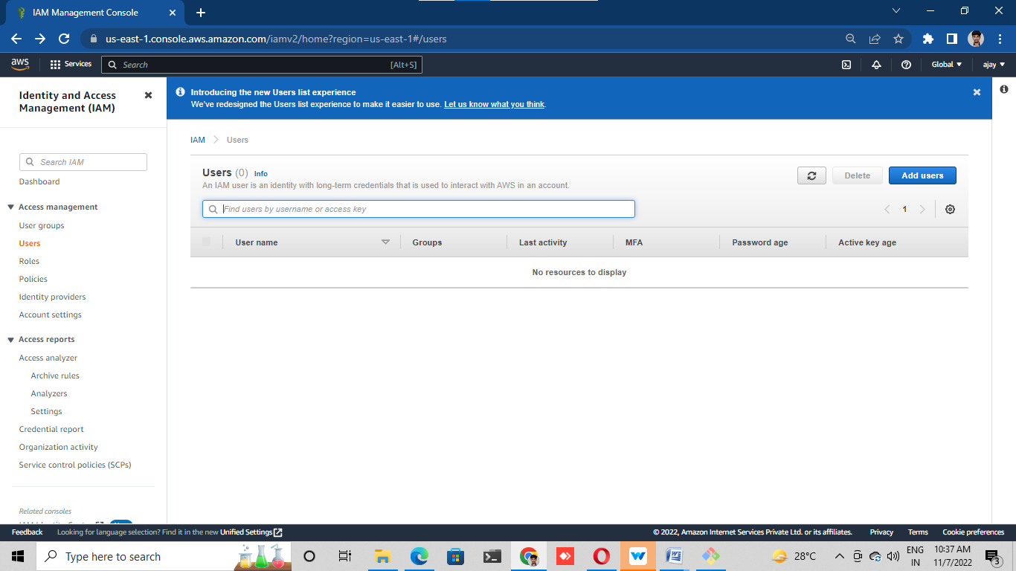

Click on add user for creating a user

Give name and add access permission “AmazonEC2full access”

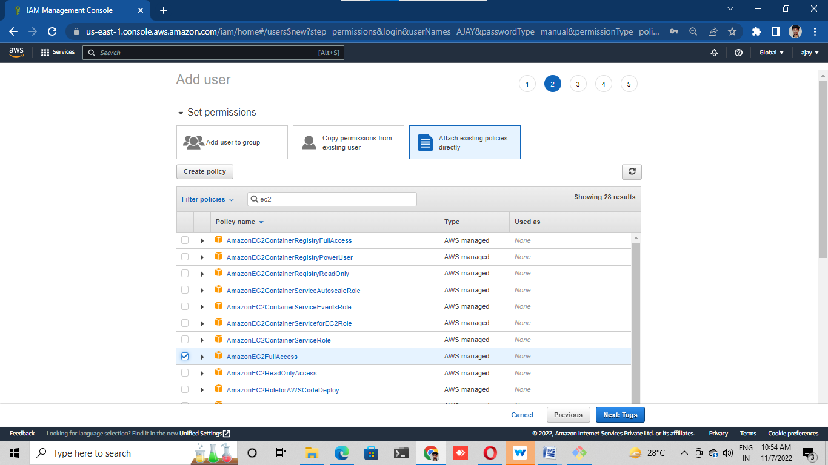

Add password for security for the user

Created the user and it will send email option for give the access for user

Go to mail click on the link and type user id and password

Check we gave access work or not.

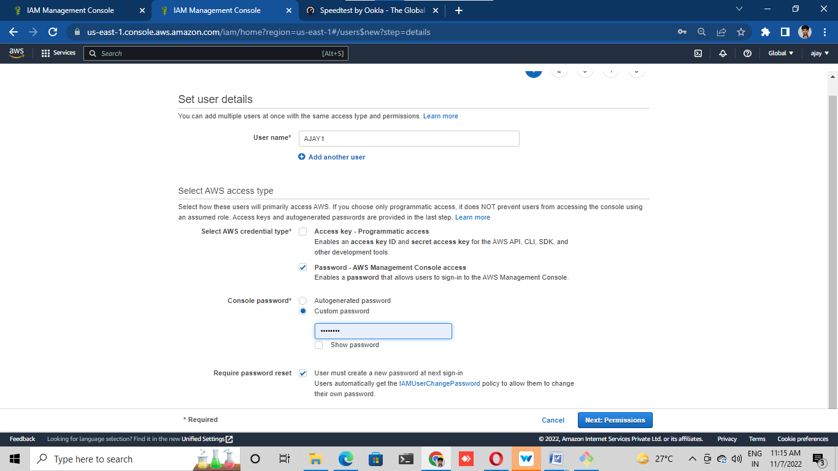

˖Check other service for example S3

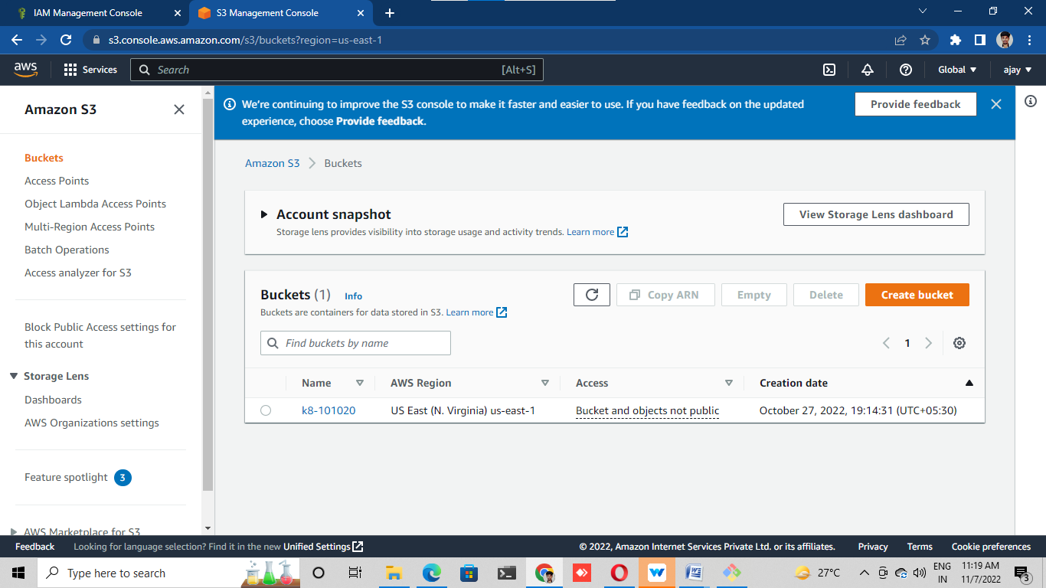

˖Add another permission as administrator access

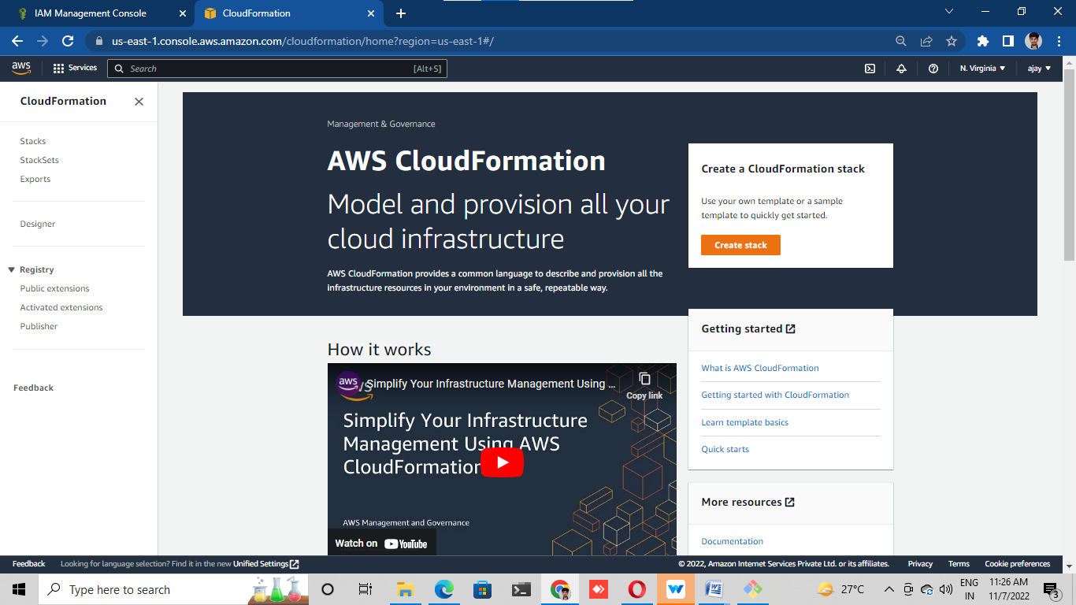

BILLING ALARM

˖Log in into AWS console

˖Go to cloud watch

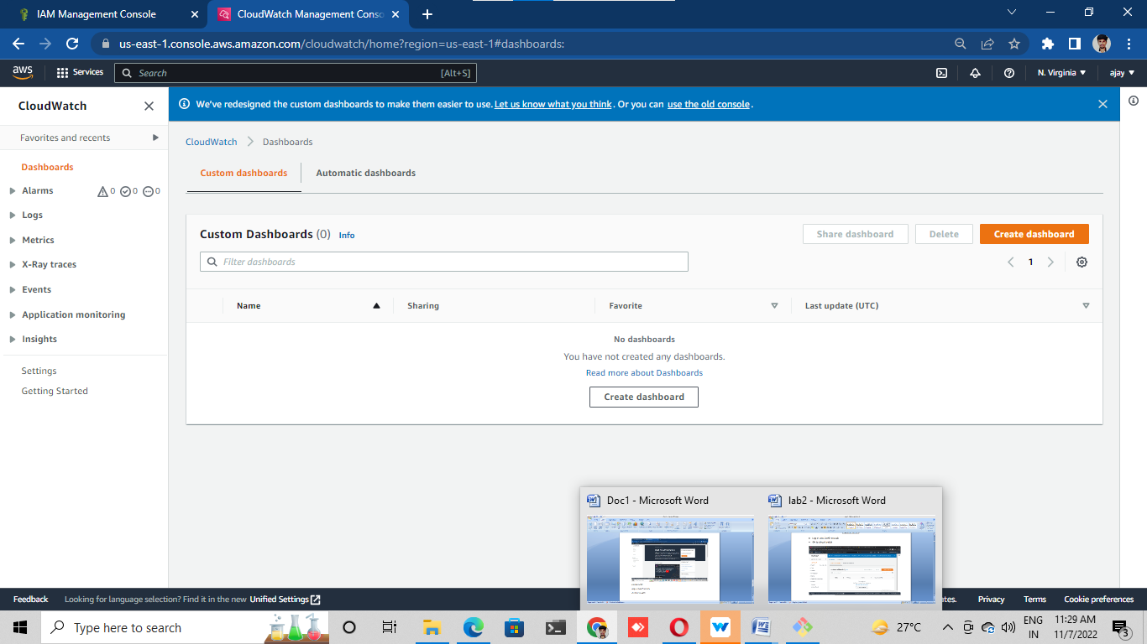

˖On the left we will find alarms

˖Click on the alarms

˖Choose the billing

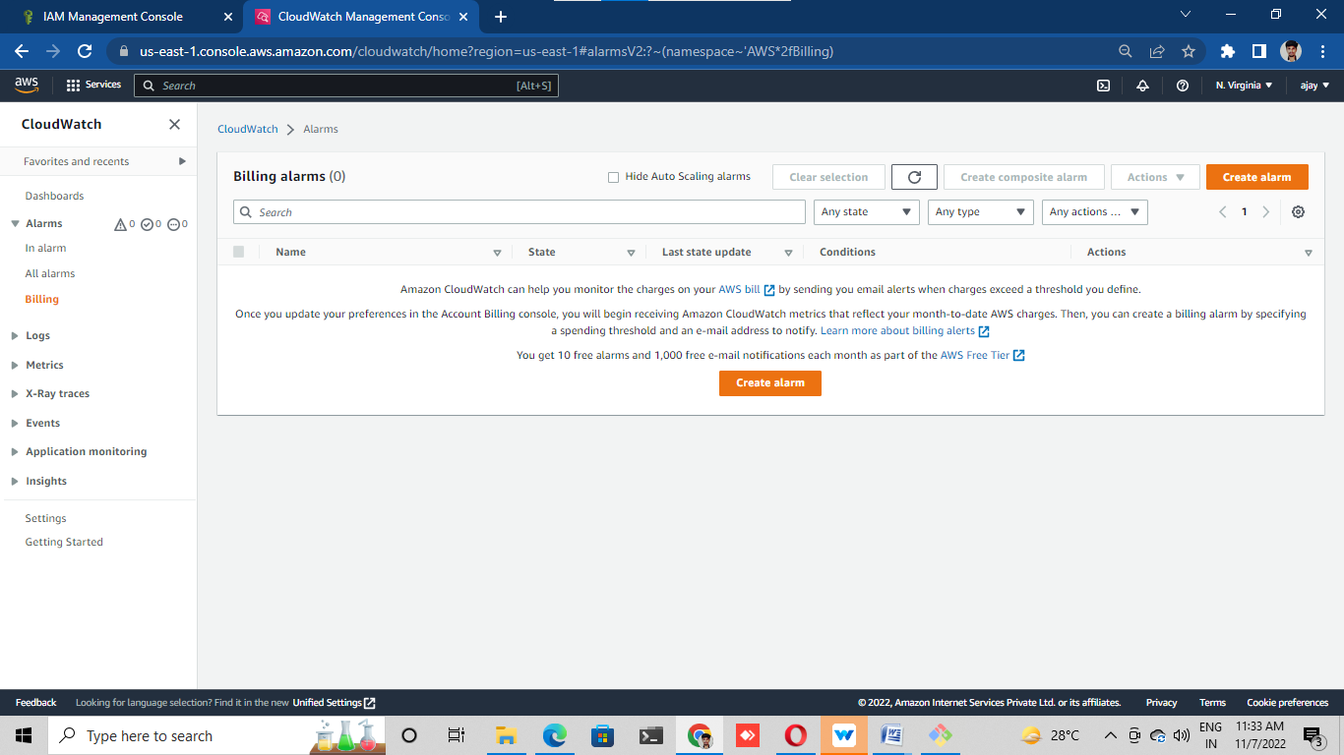

Click on create alarm

First stage is specify the metric and conditions

Select metric

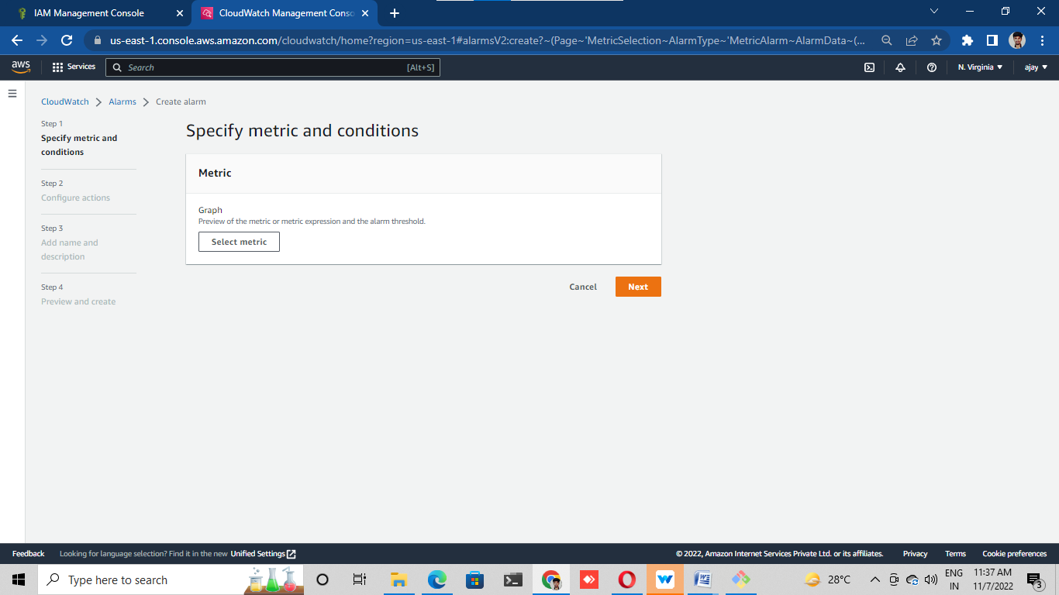

˖Select EC2 and pre instance metric (select any instance)

˖Give conditions

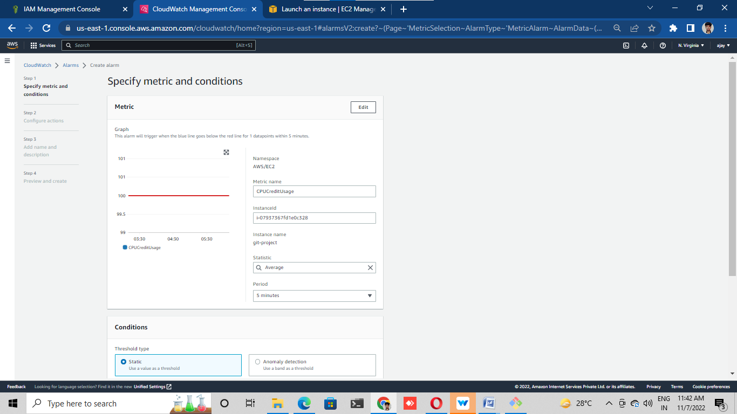

˖Give notifications

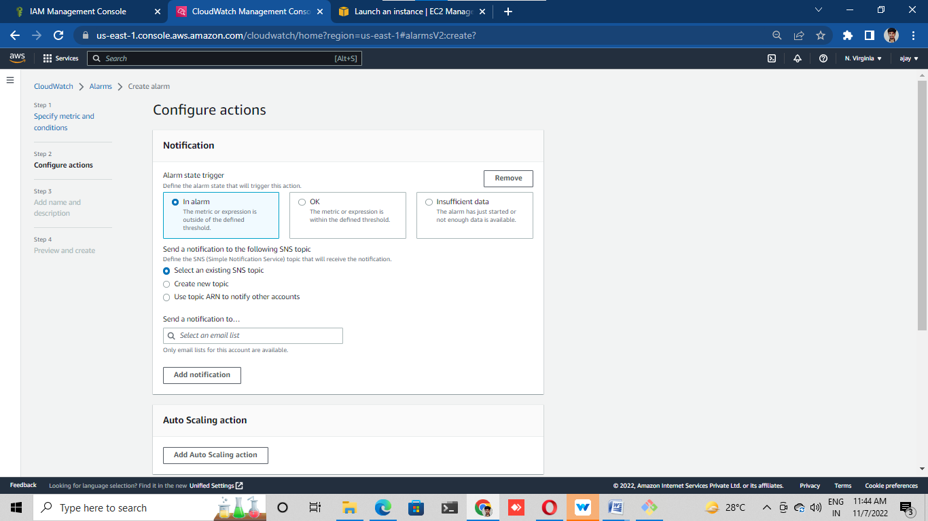

˖Add name and description

˖Created alarm for billing

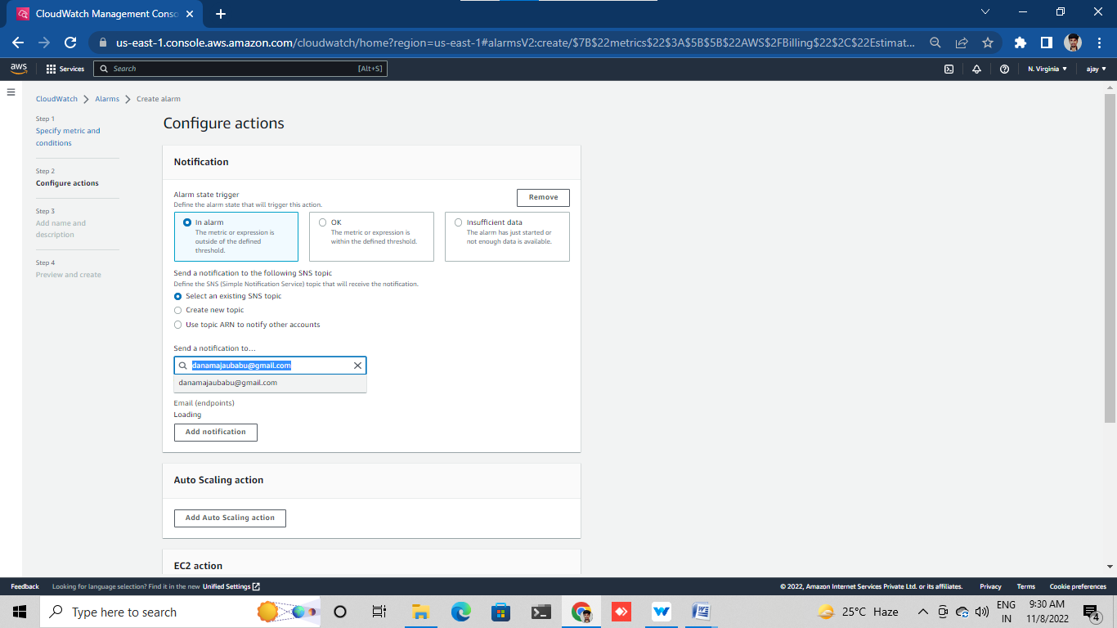

Add name and description

Created alarm for billing

Creat s3 bucket

Login to aws console

Go to s3

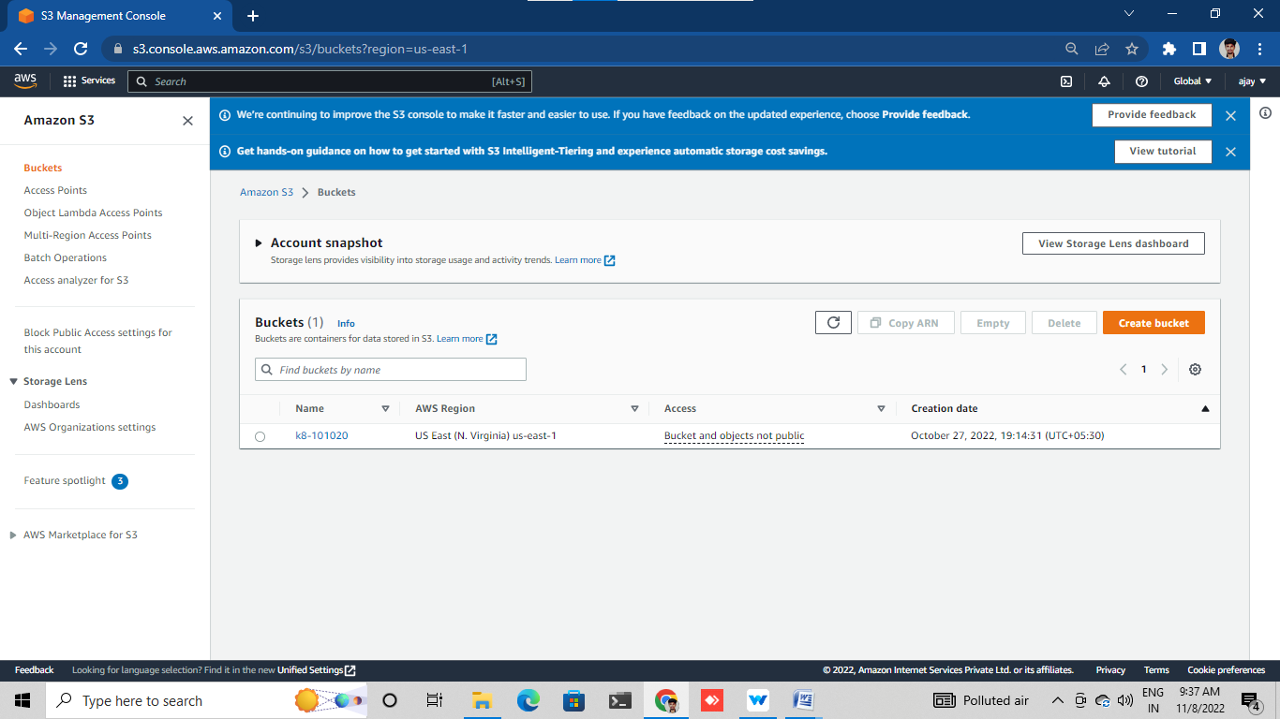

Creat bucket

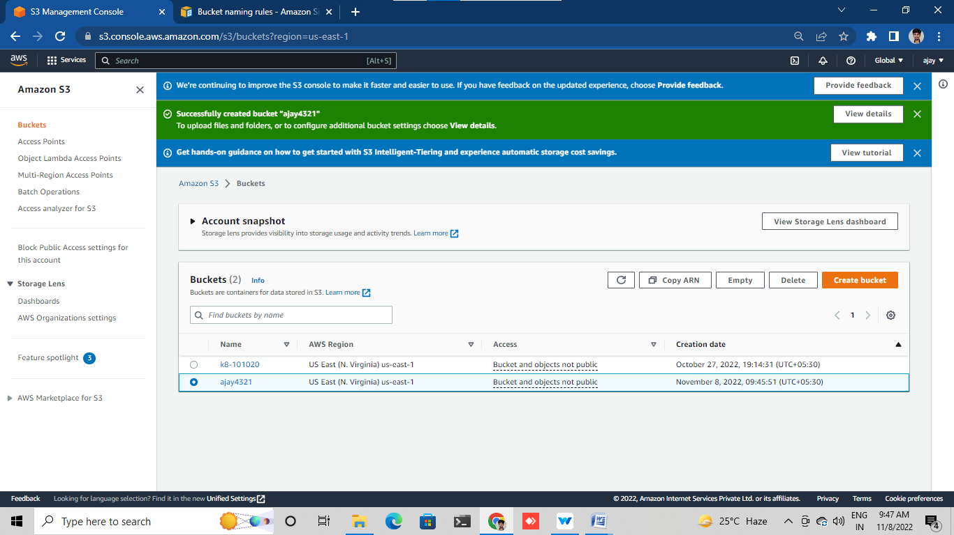

Click on that s3 bucket

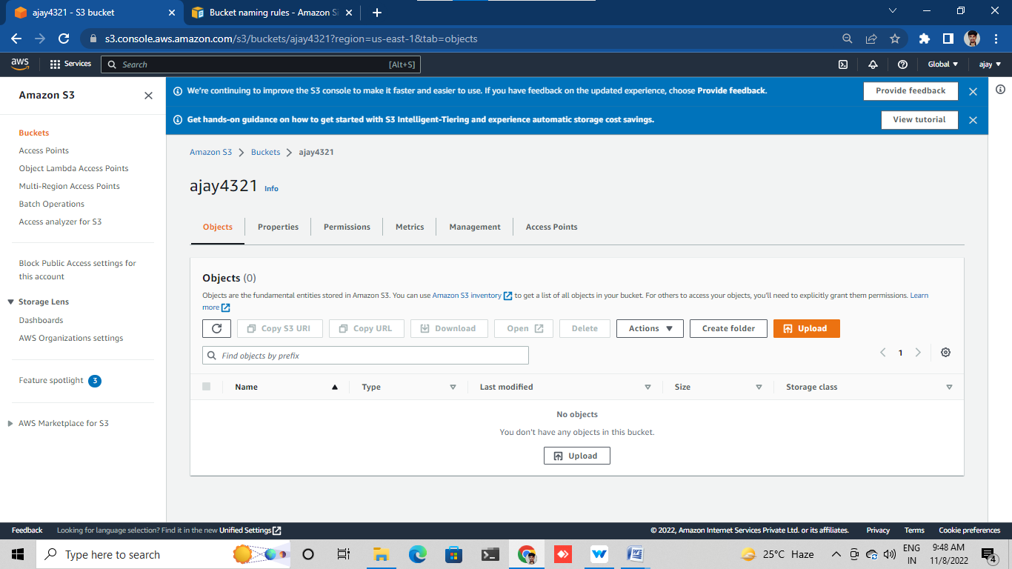

Click on upload

Click on add file

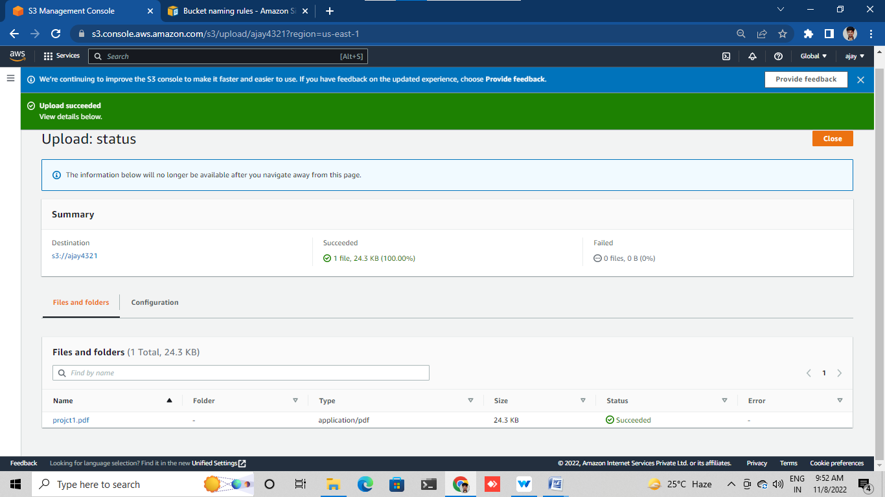

Click on upload file

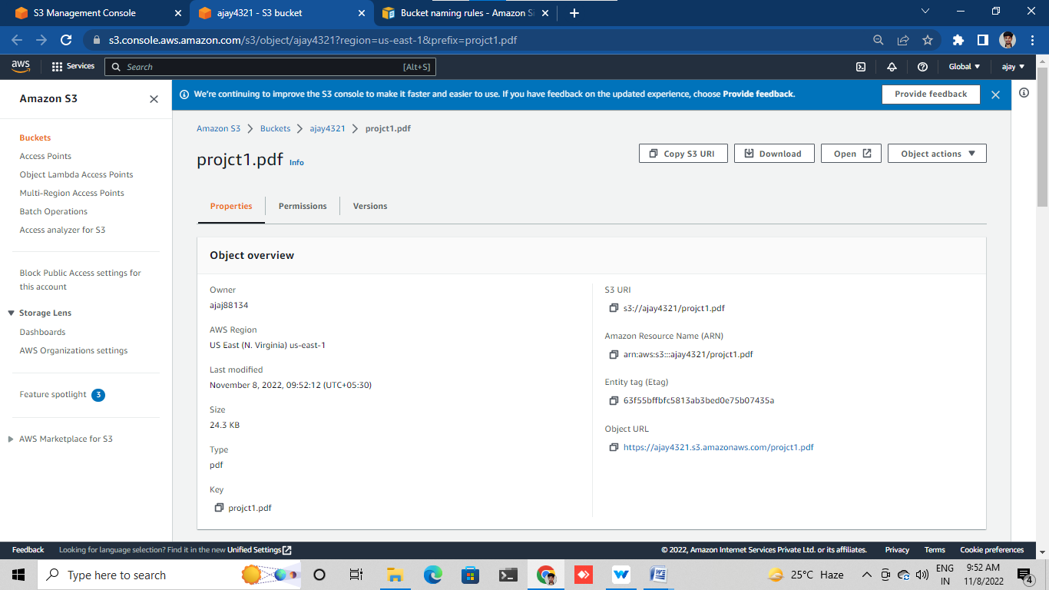

Copy url of s3

Paste in google tab and search

Then we will get error

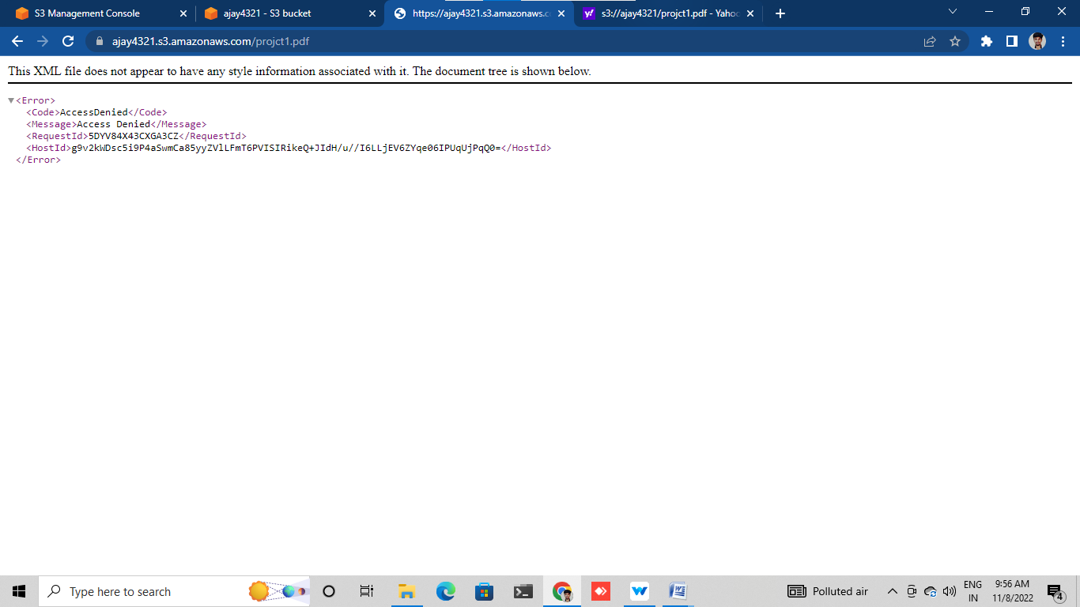

Click on bucket name

Go to permission

Turn of the block public access

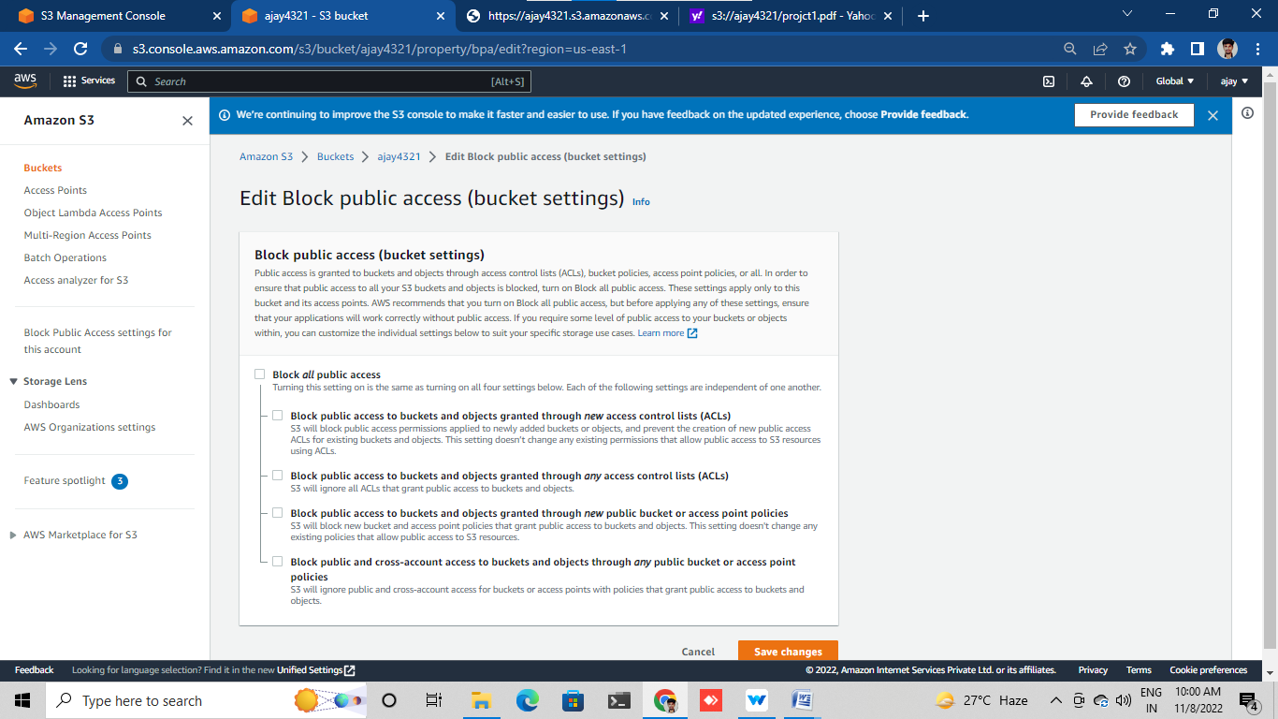

Click on ownership and enable it

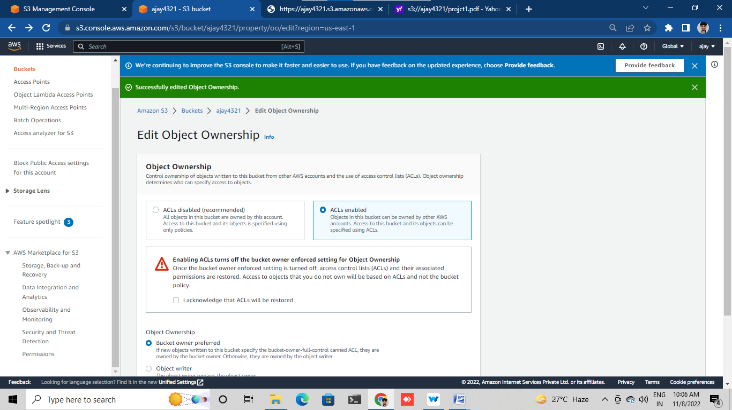

Select the uploaded file

Go to action

Make the public using ACL

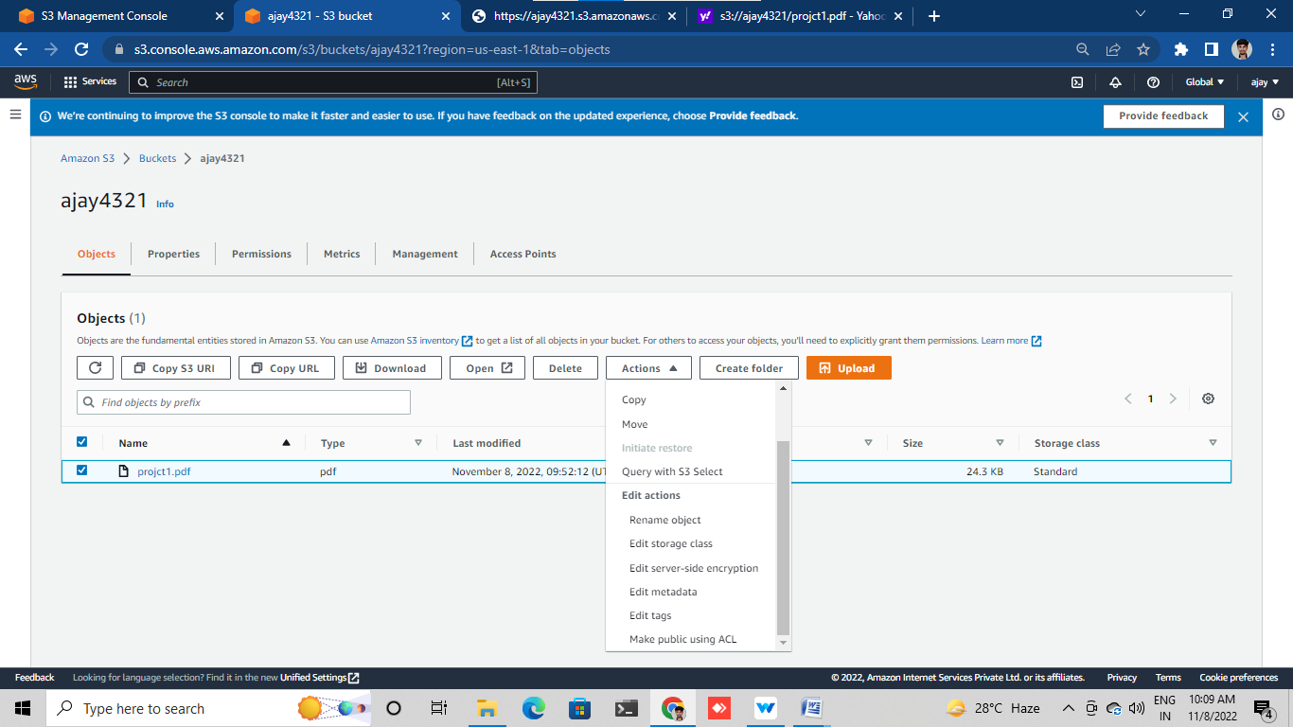

Copy URL of uploaded file

Paste in google tab

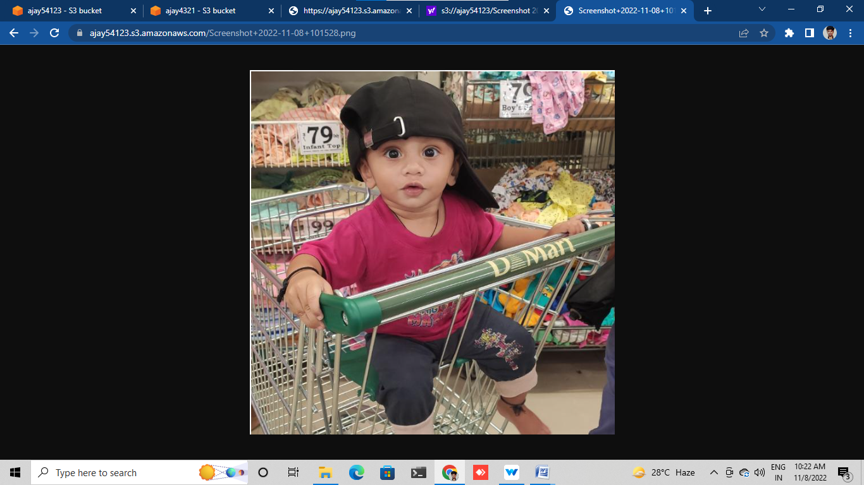

Edit bucket versioning enable it

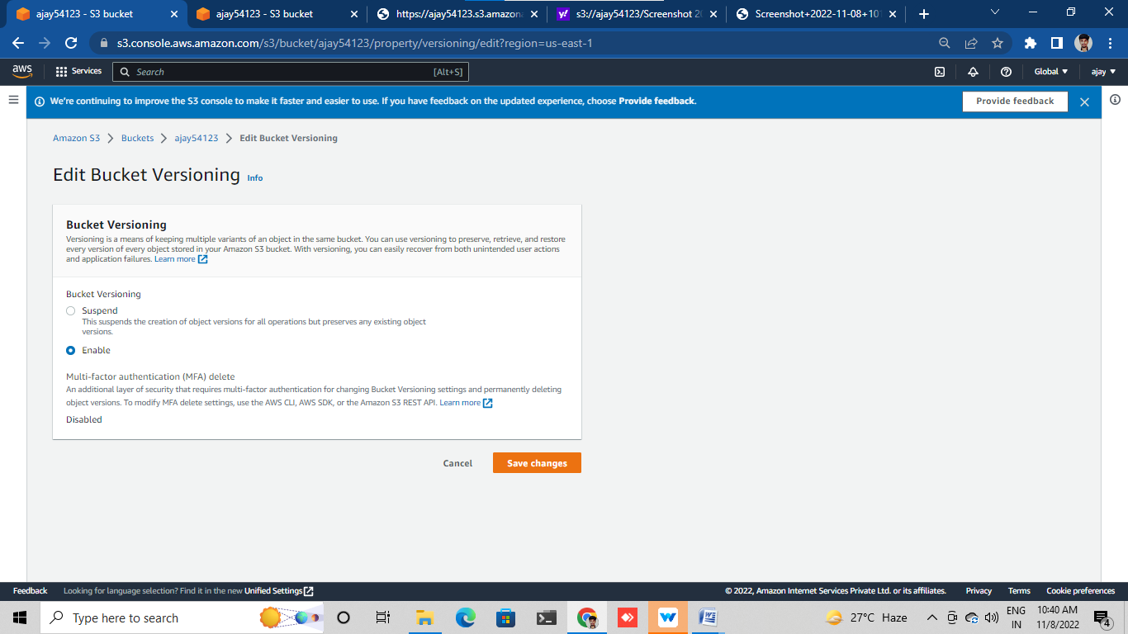

Up load file

Make it public

Copy URL of uploaded file

Paste in google tab and search

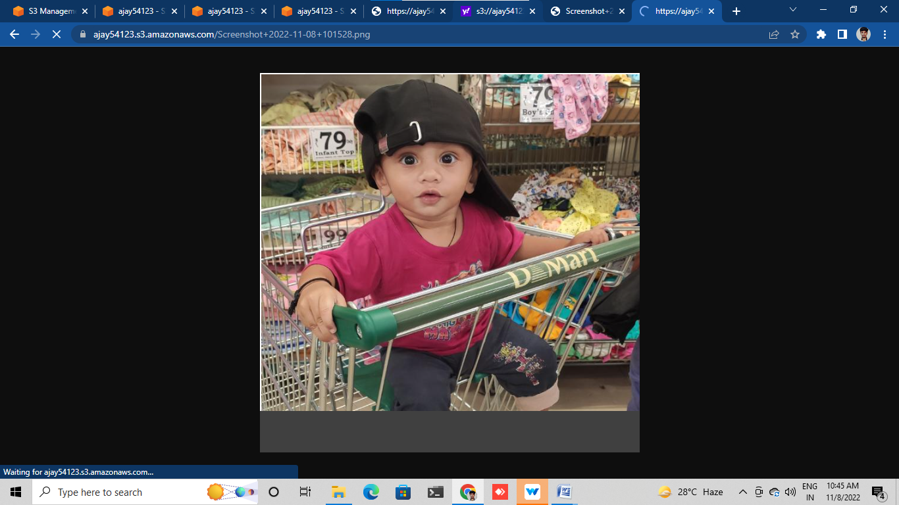

Delete the text file

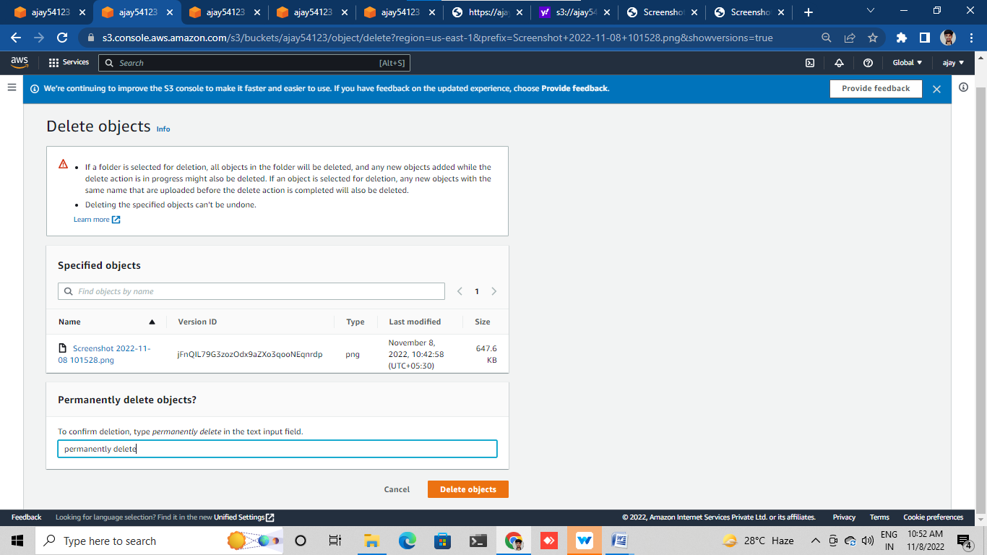

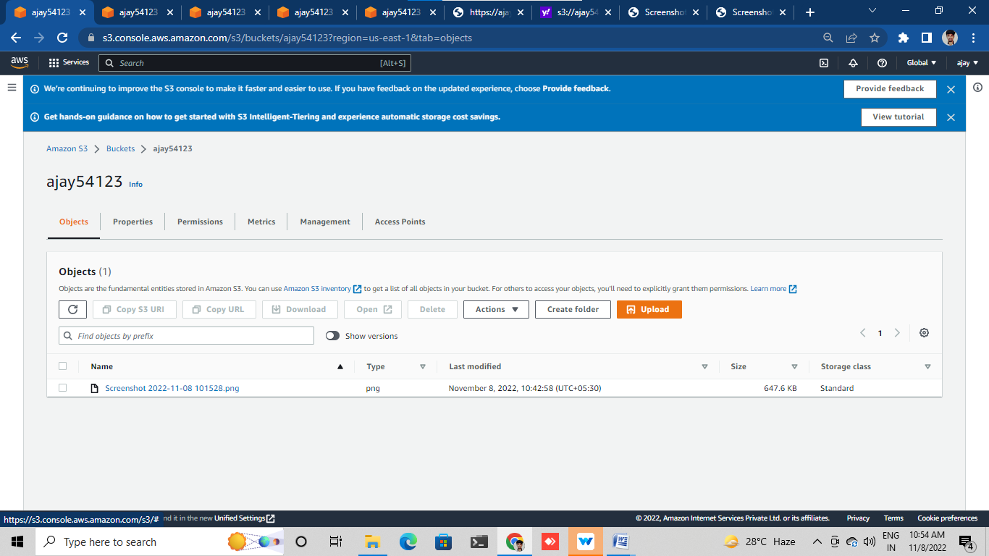

Check file and recovery file for delete maker file

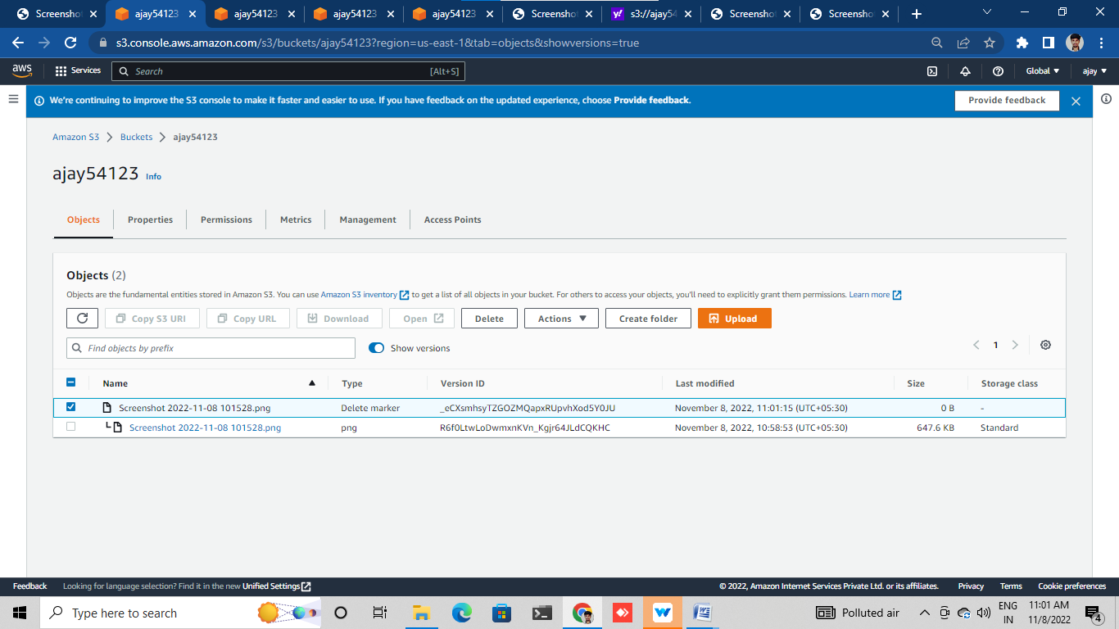

Show versions

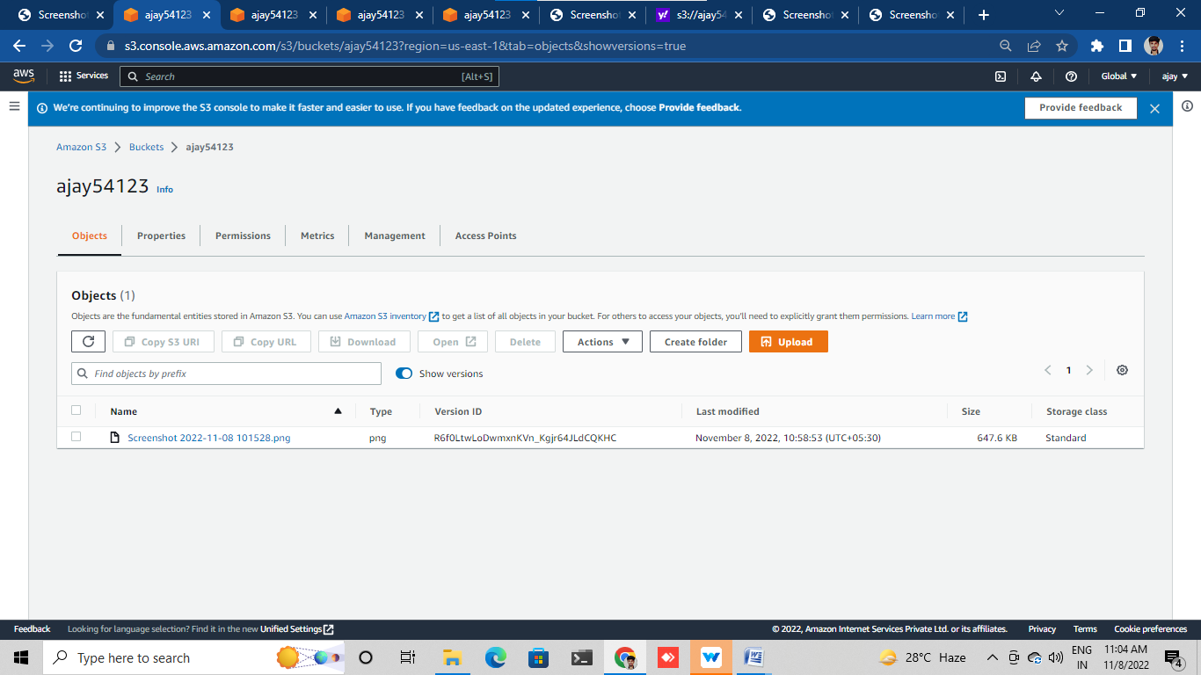

# CREATE EC2 INTANCE

Log in to aws console

Go to ec2 click on instance

Click on launch instance

Give name and select ubuntu AMI

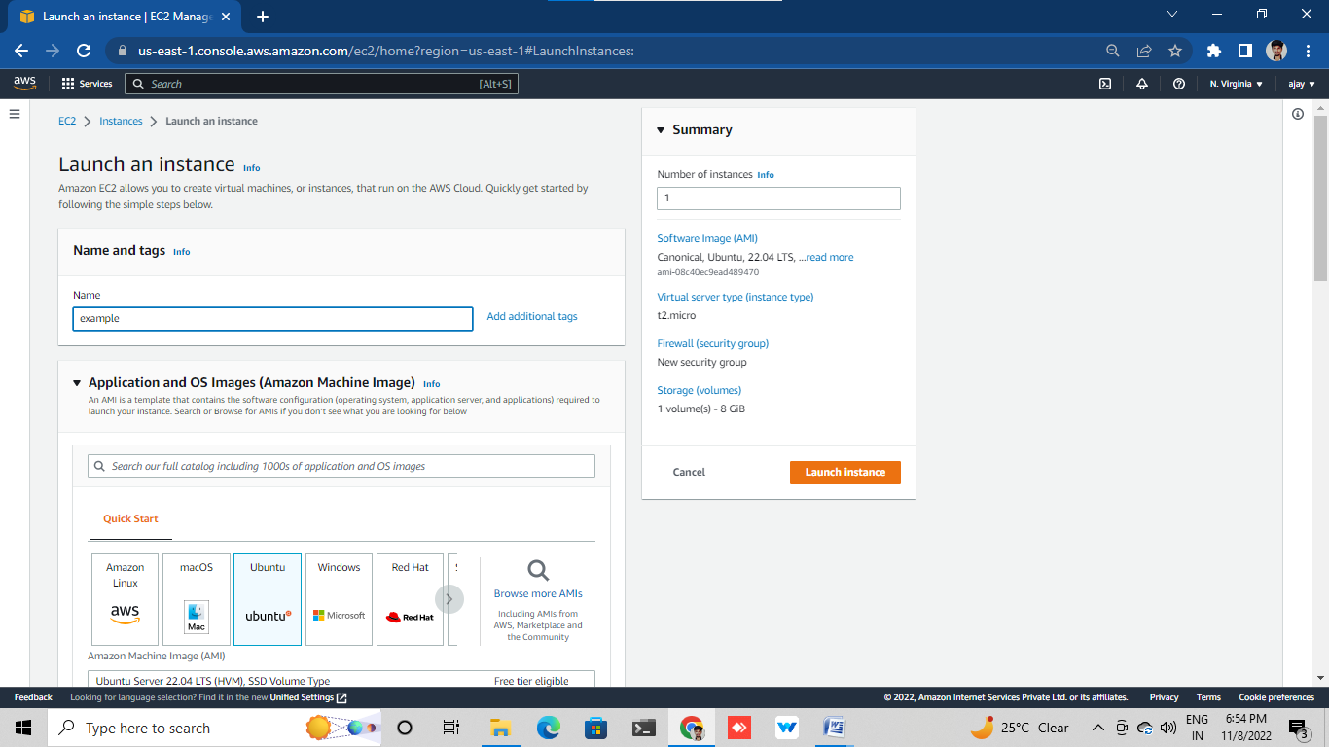

Give t2.micro

Select key pair

Choose group

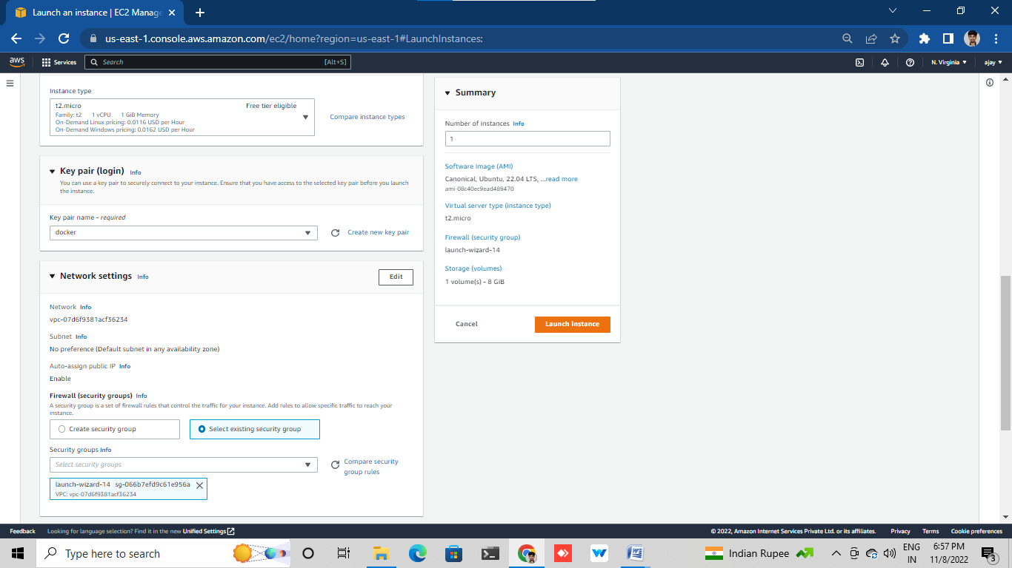

Launch instance

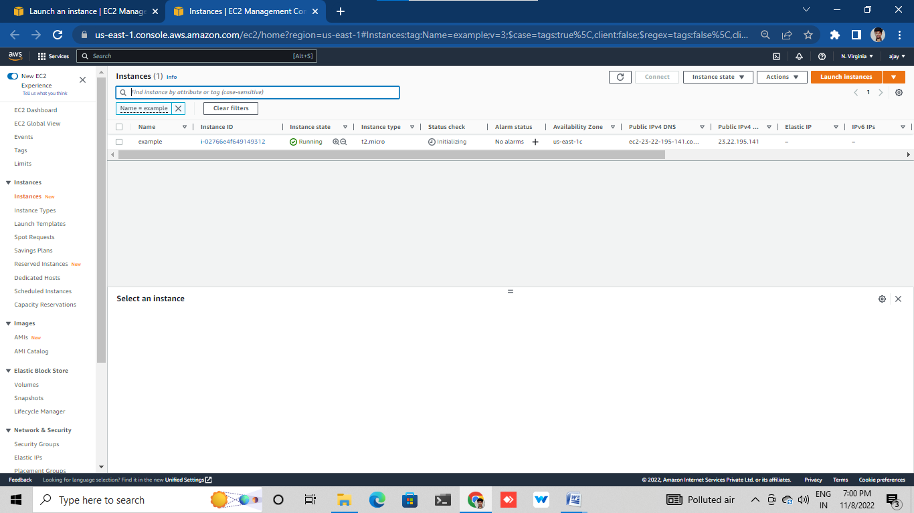

Connect instance with git bash /putty

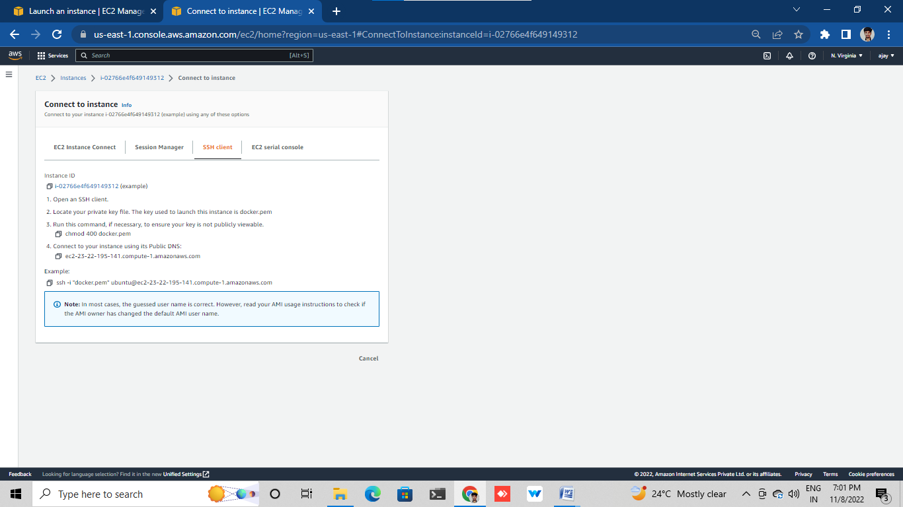

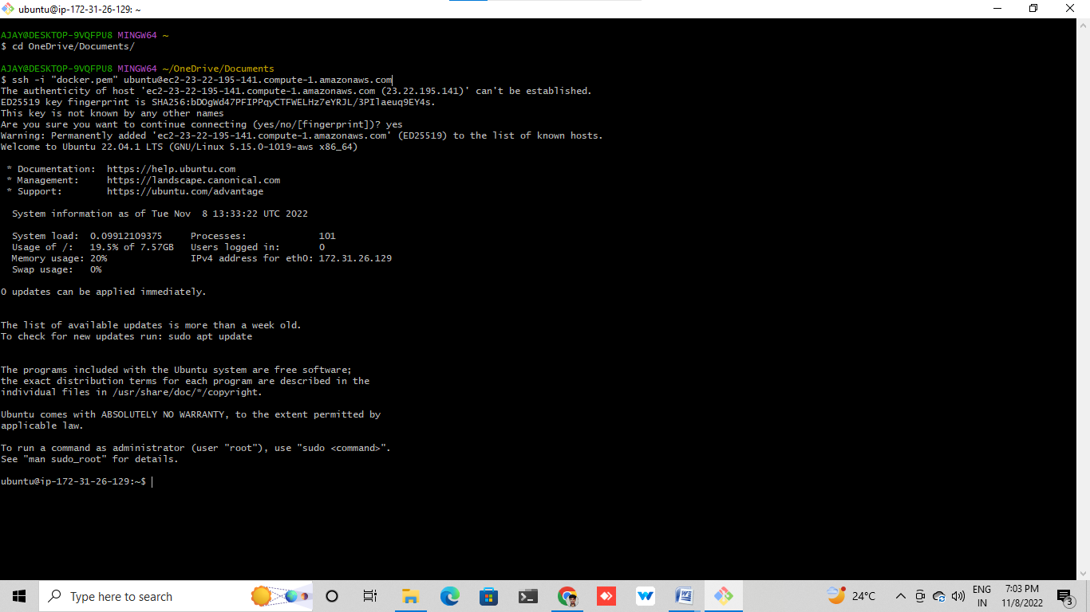

Create New Security Group

Log in into AWS console

Go to security group

Create security group with name mygroup

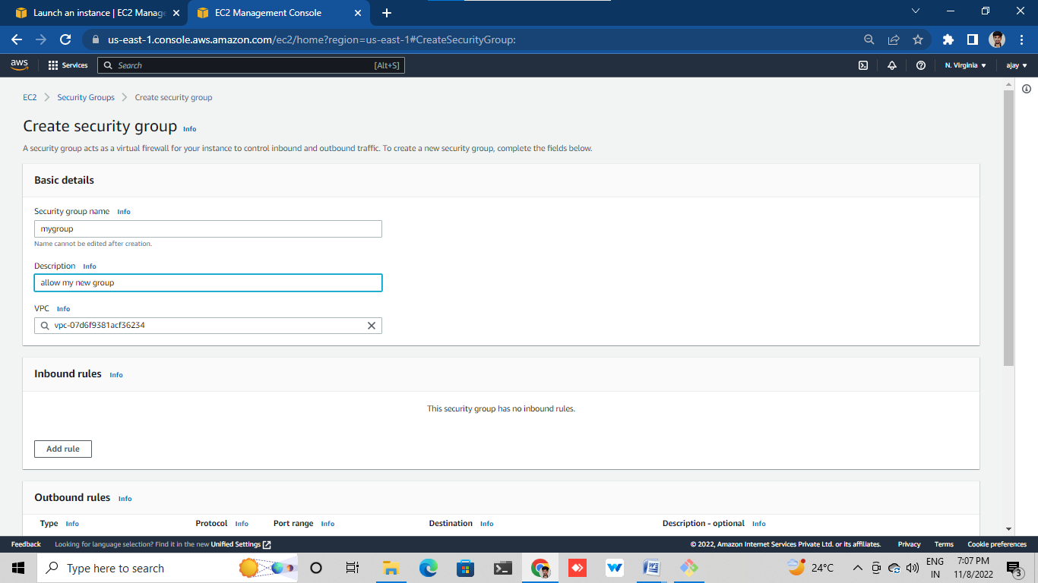

Give the inbound rules(SSH-22,HTTP-80)

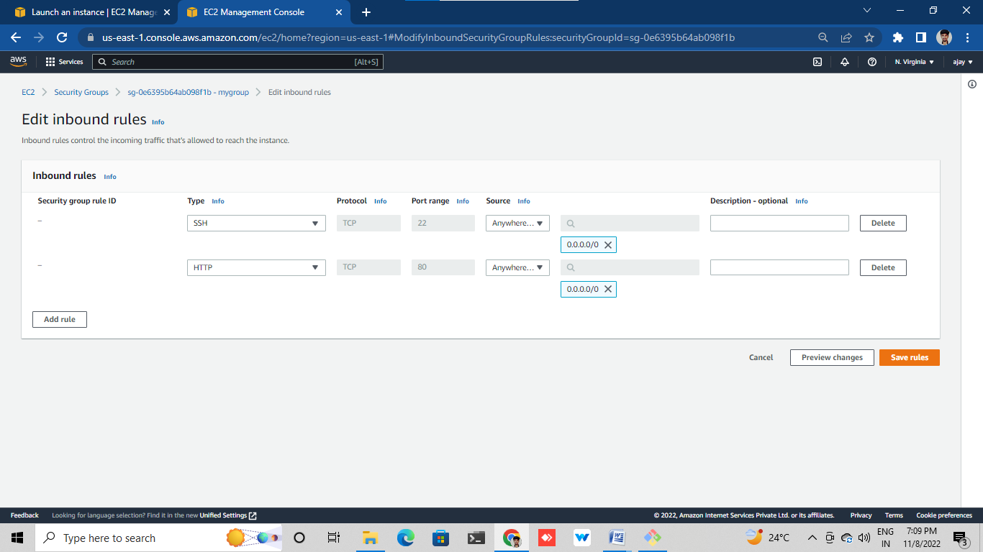

Create EC2 attach with new security group(created one)

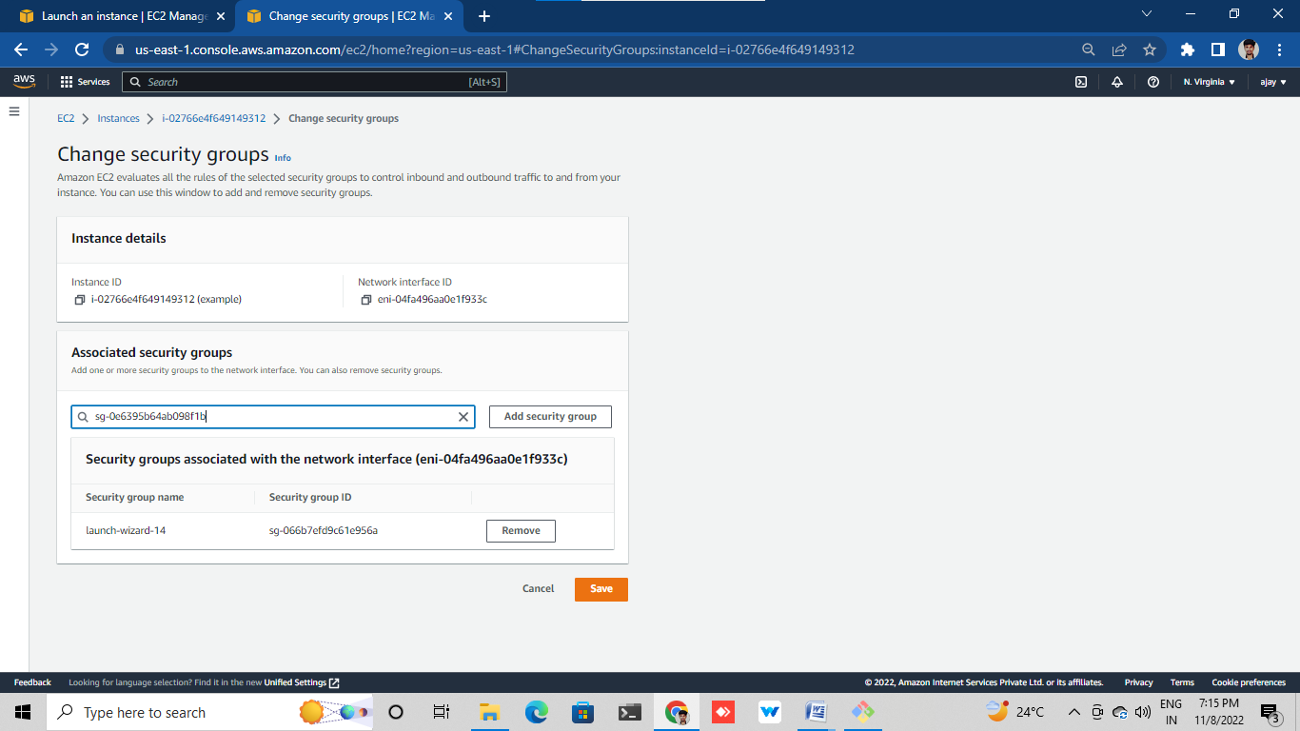

Create new EC2 attach with new security group

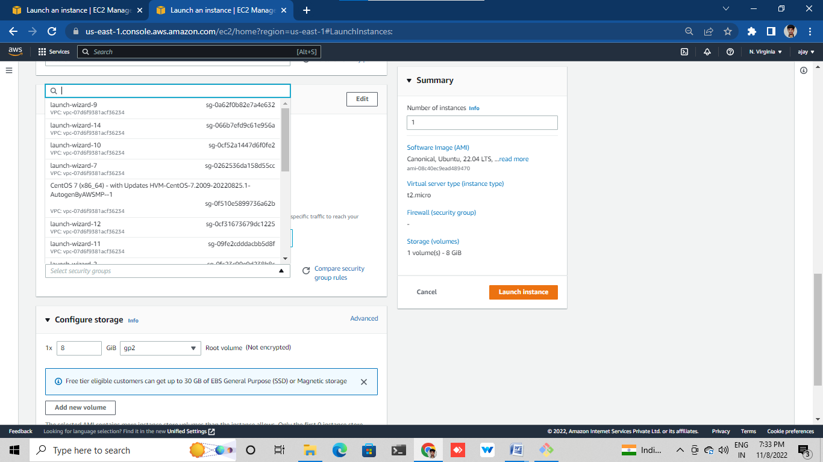

# VOLUMS

Log in aws console

Go to ec2 and launch instance

When launch instance add storage 5gib launch instance

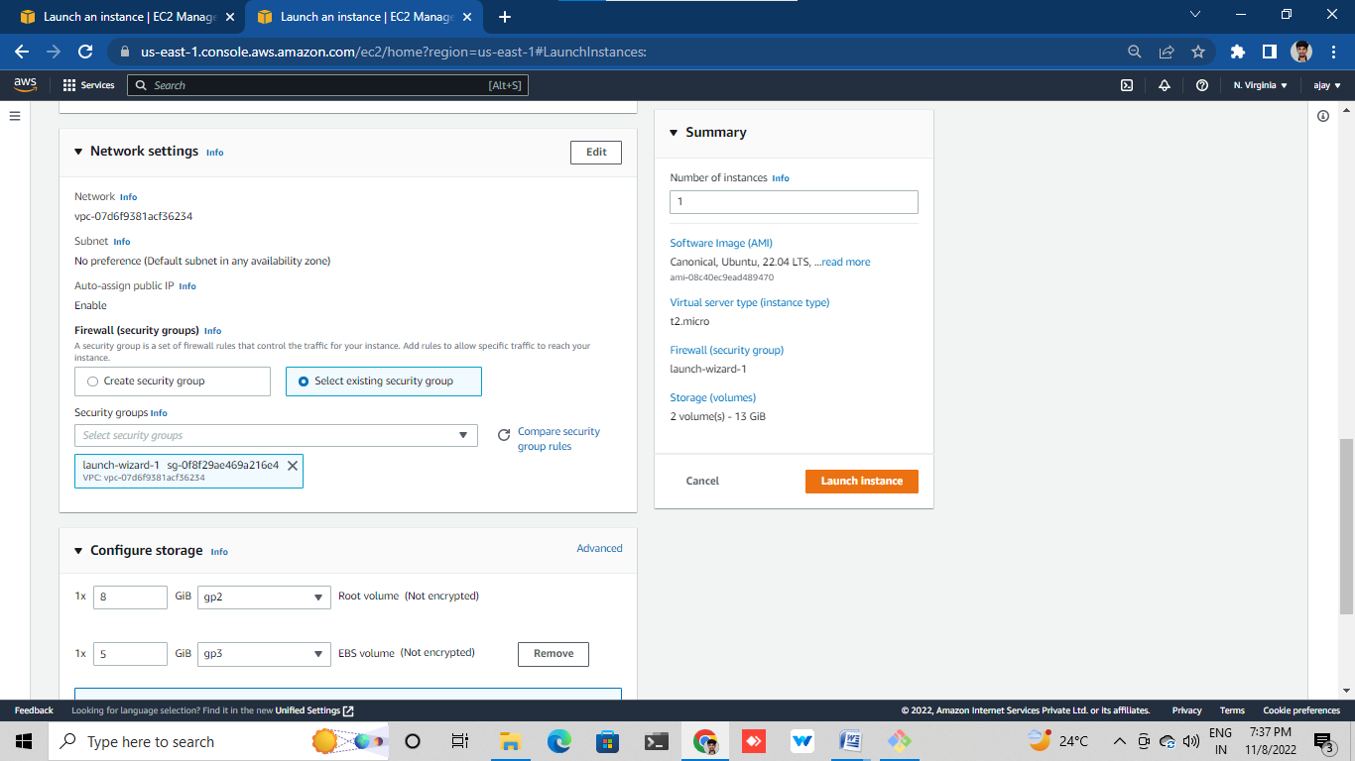

Connect the instance in terminal

Type (lsblk) command

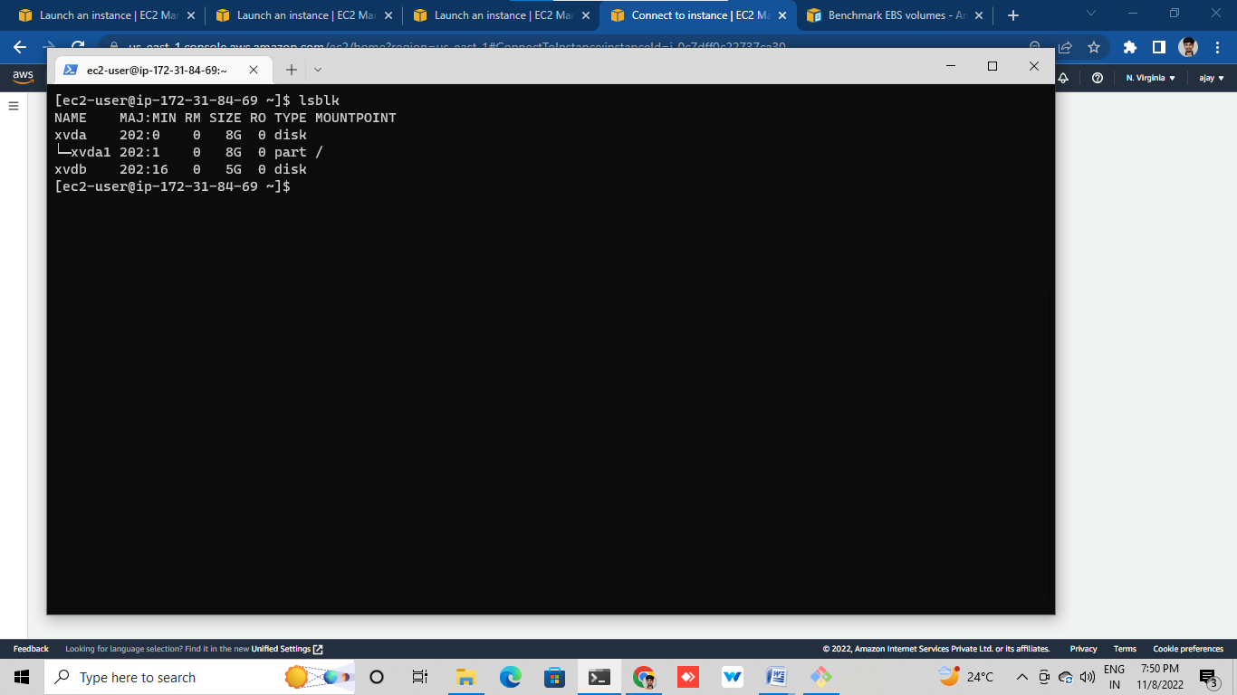

**in terminal**

first format the volume by using (sudo mkfs –t ext4 /dev/xvdb)

create a directory (mkdir <file example-lost found>)

download the test file from the browser (Wget <https://speed.hetzner.de/1GB.bin>)

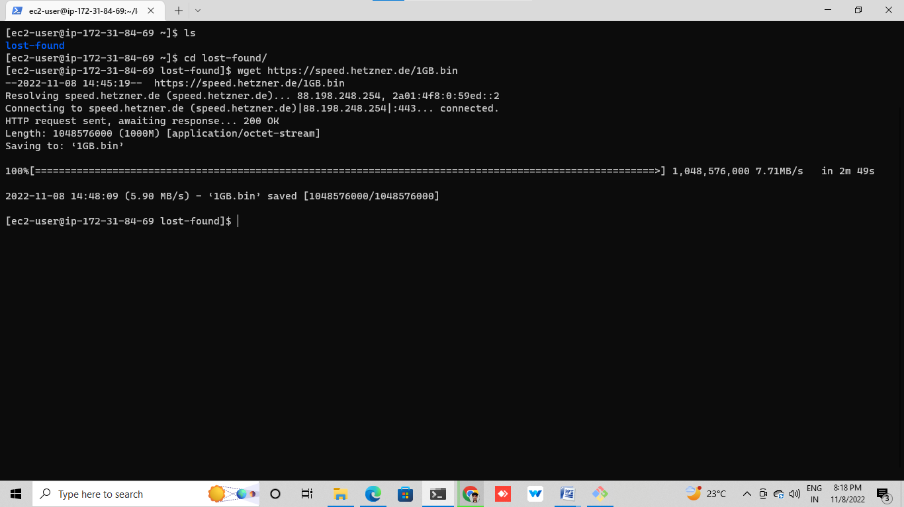

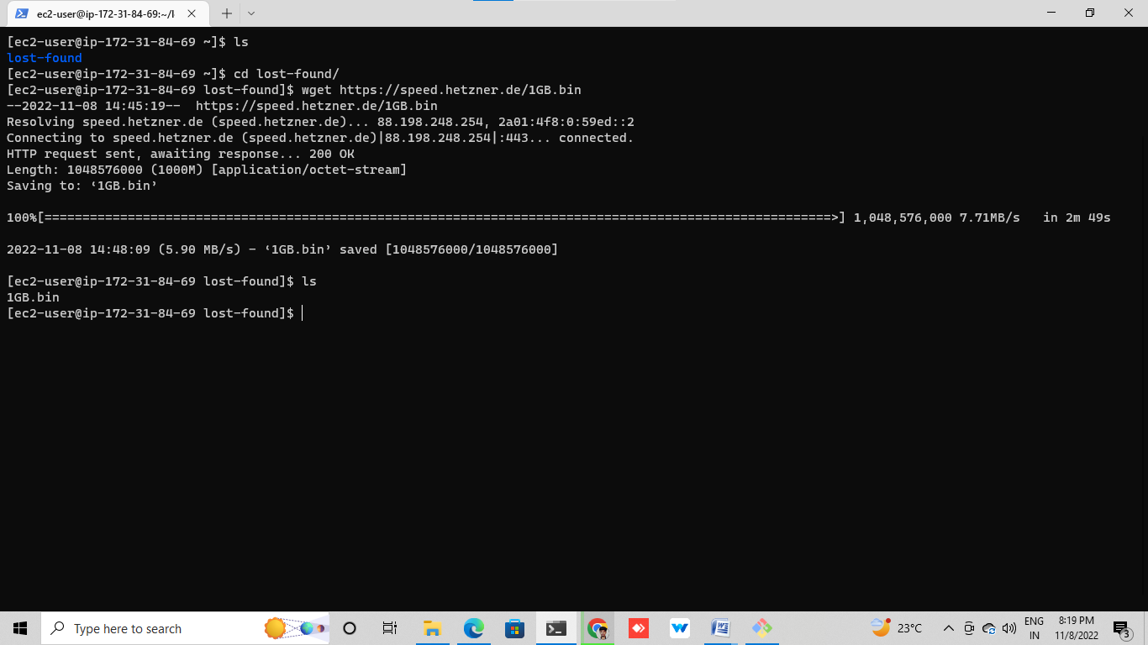

Type command (df -h) show the storage

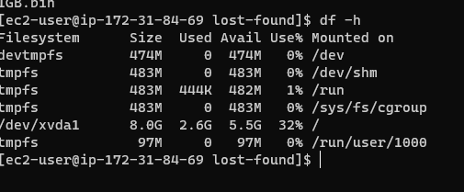

Go to volumes and select the required

Go to action and click on modify volume

Modify and save it

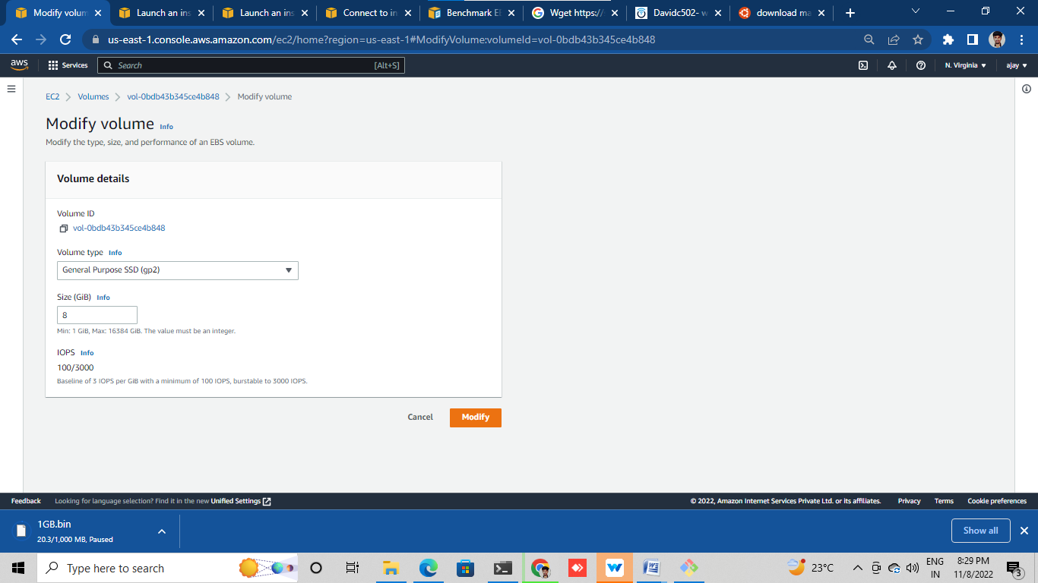

Go to snapshots

Create a snapshot for required and save it

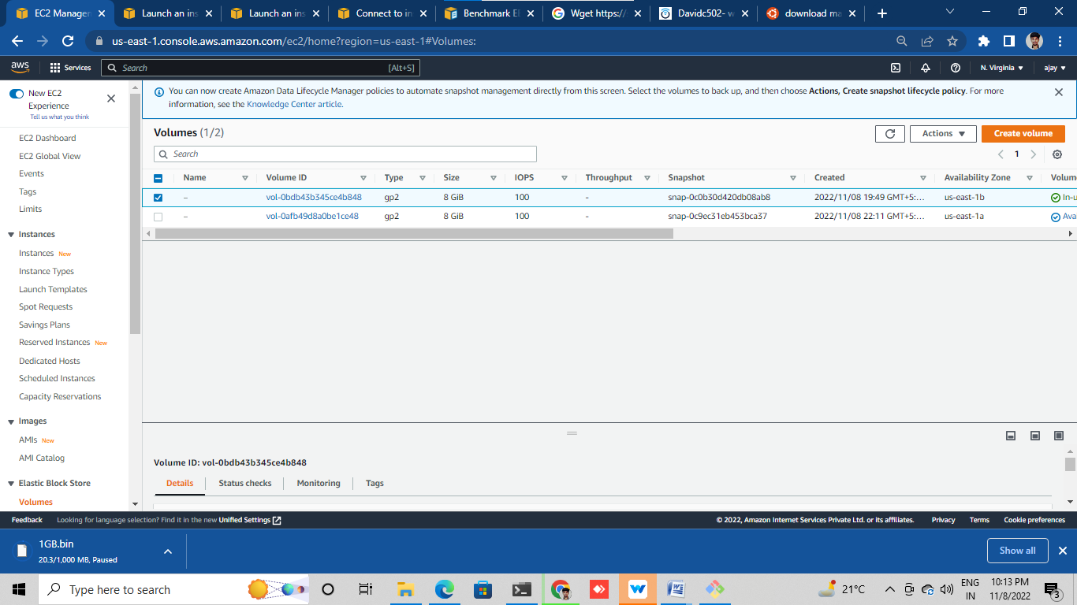

Delete volume which one create snapshots

Create a volume for snapshots

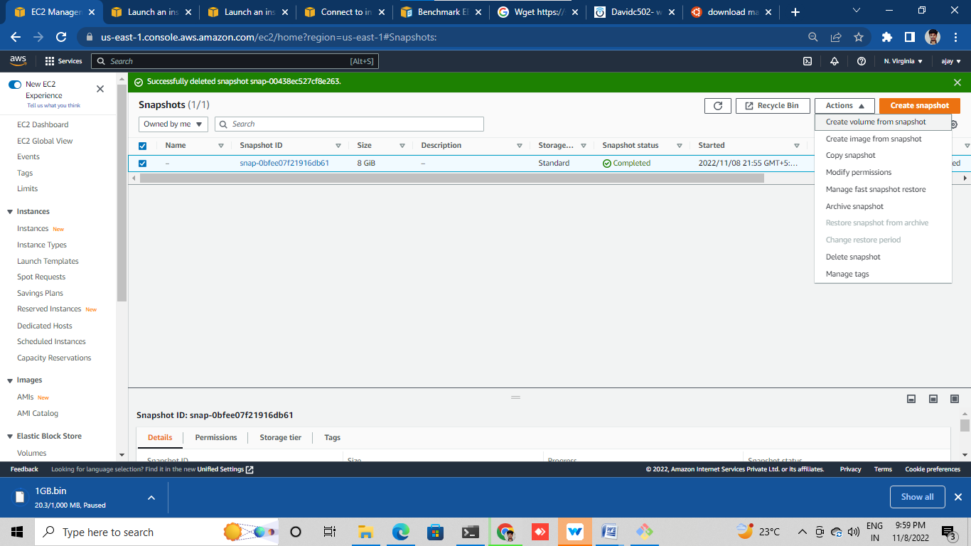

Attach volume is created from snapshot to ec2 instance

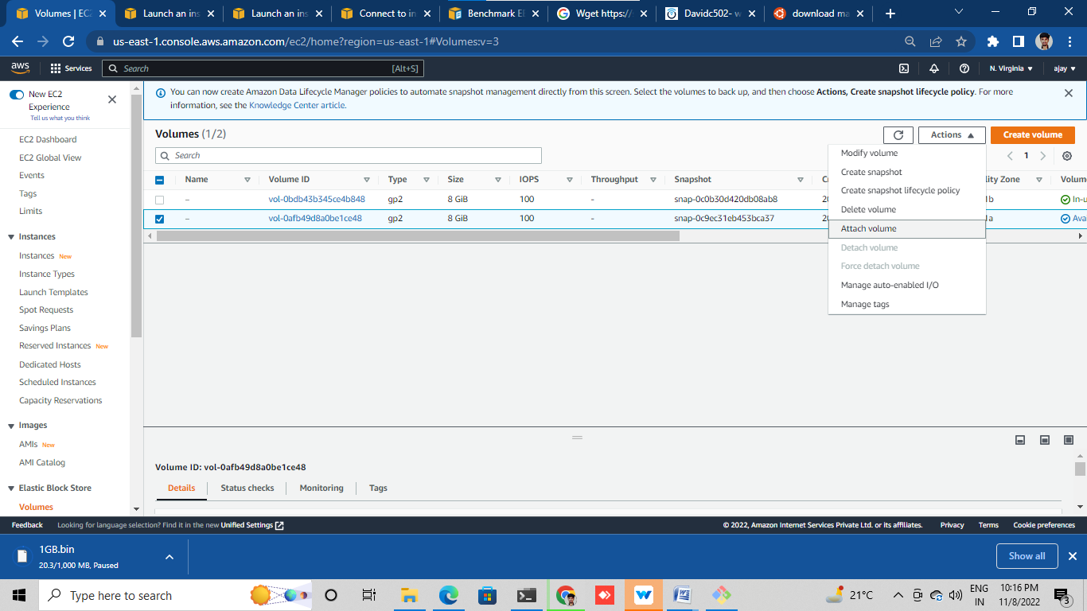

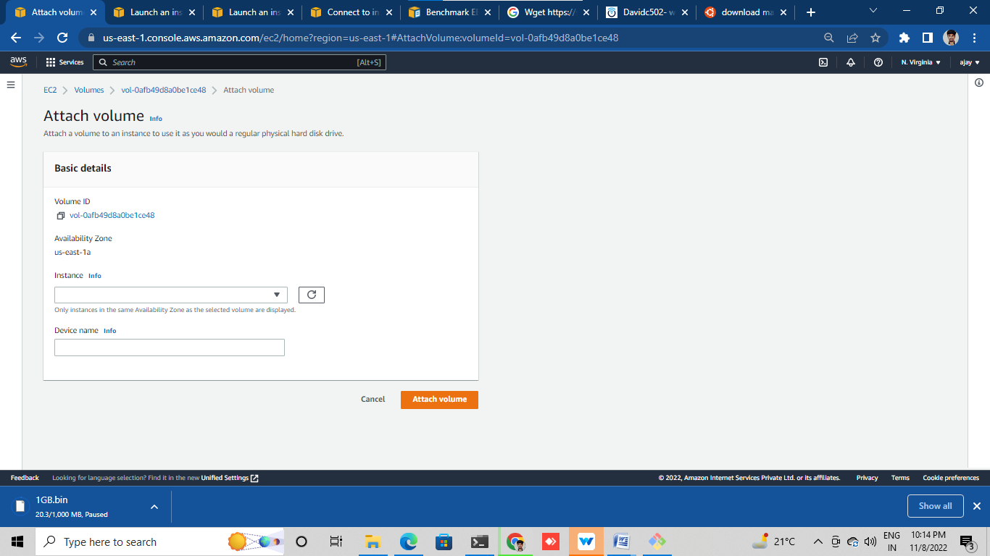

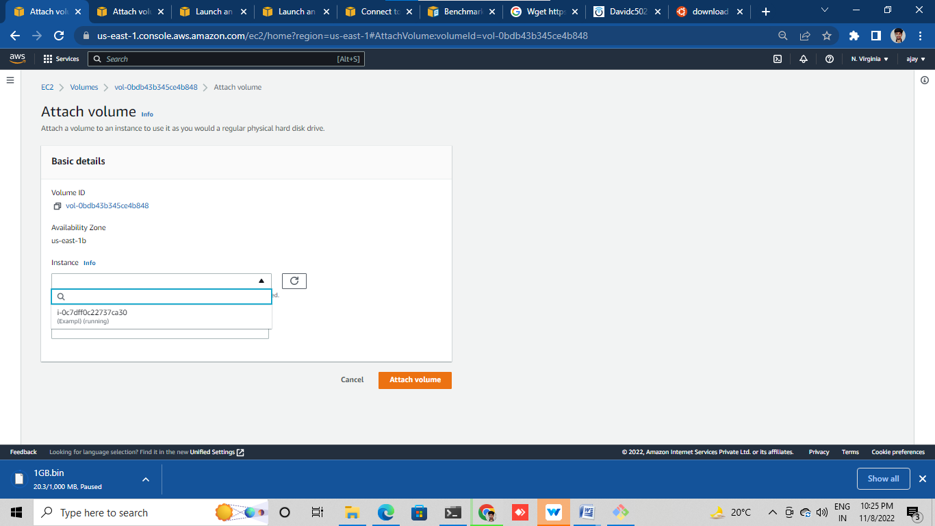

AMAZON MACHINE IMAGE

Log into aws console

Go to EC2 and launch instance with some specifications

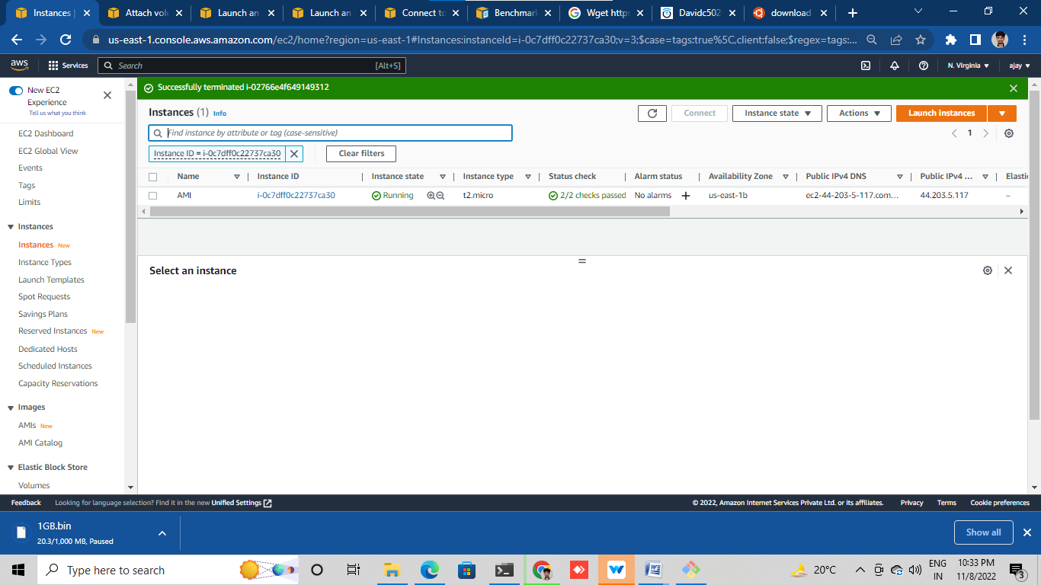

Select running instance and go to actions

Click on image and template

Click on create image

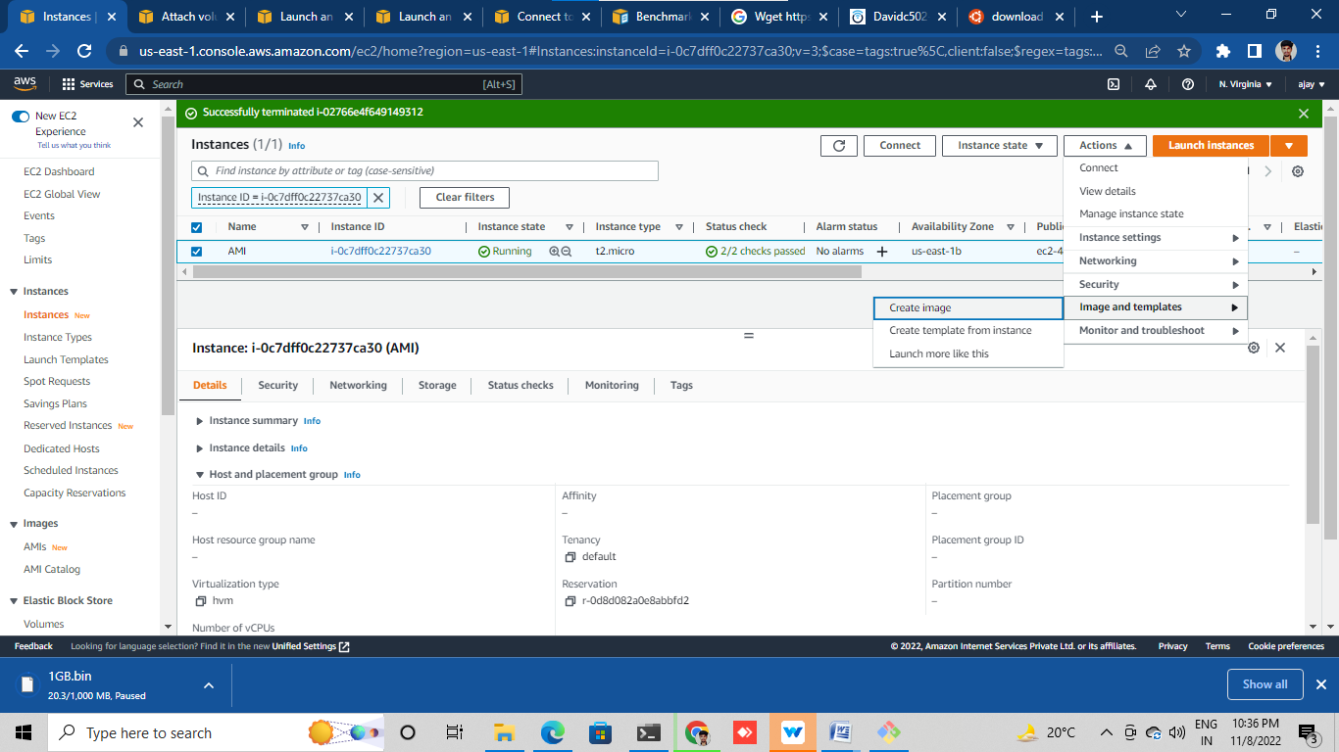

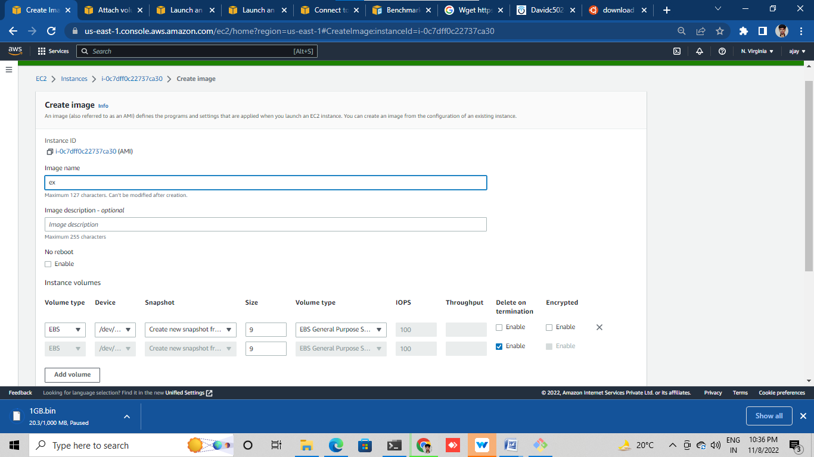

Create the AMI

It will show in my AMI (launch instance

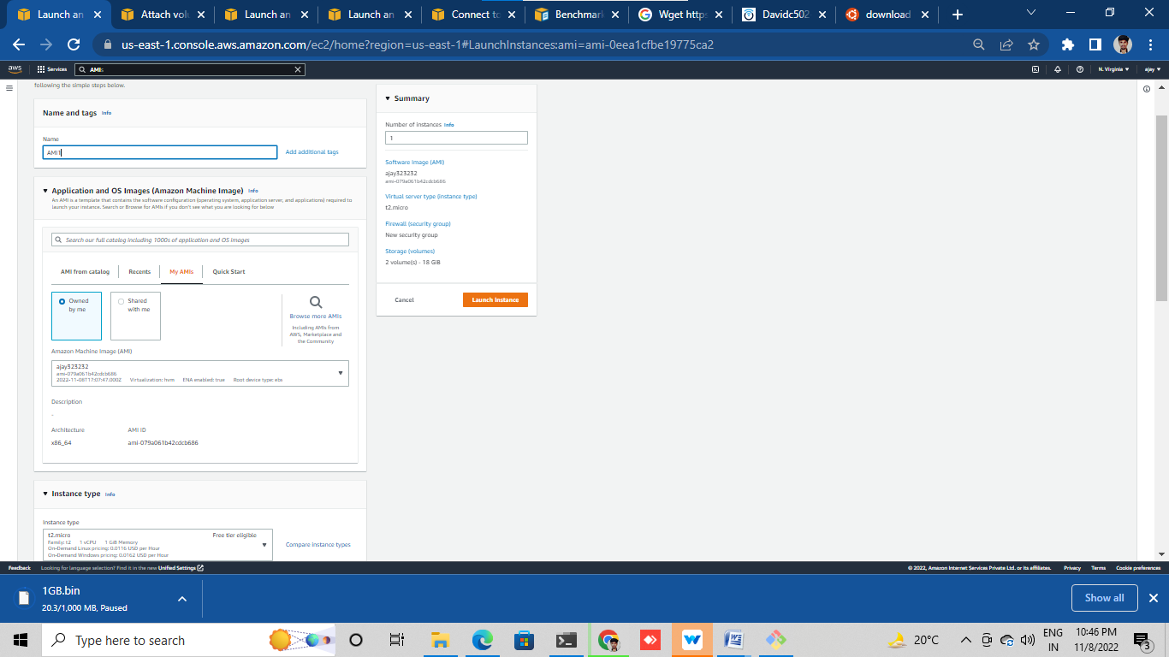

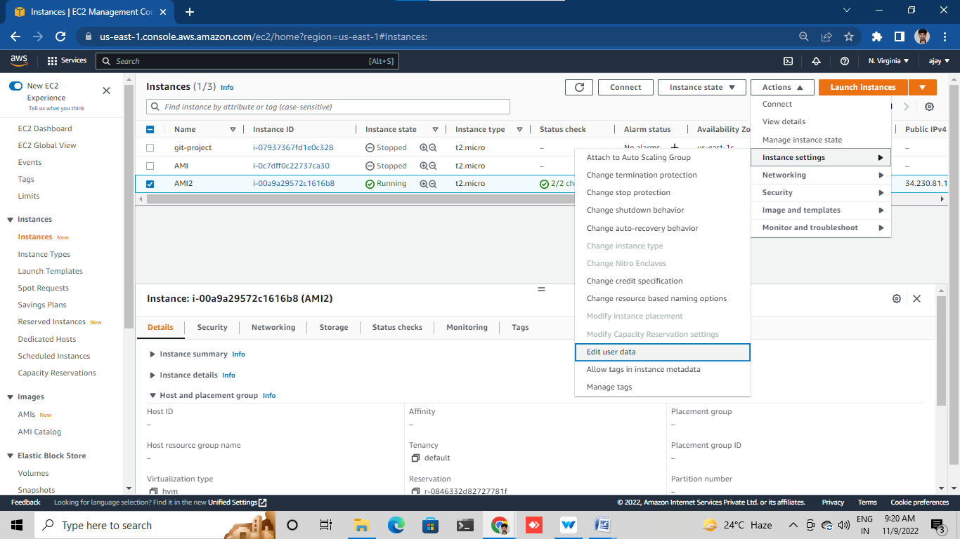

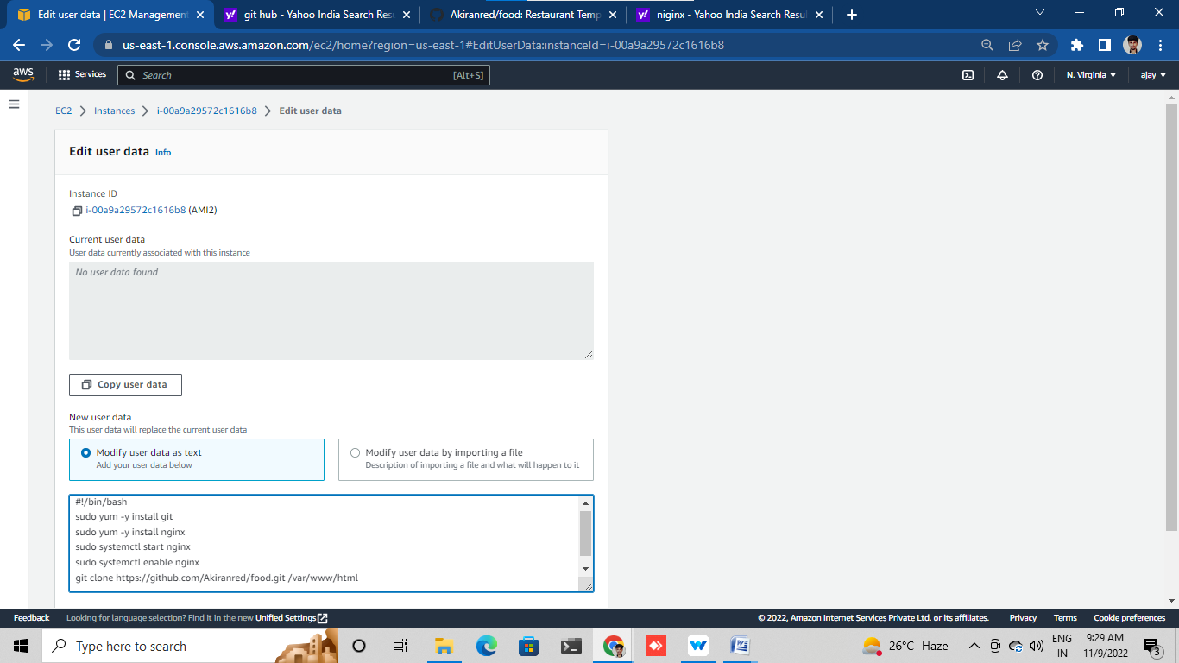

**LOAD BALANCER**

Launch instance with Nginx port and ecomm application in user data

Launch another instance with httpd server port and food application in user data in another availability zone

Check these both instances



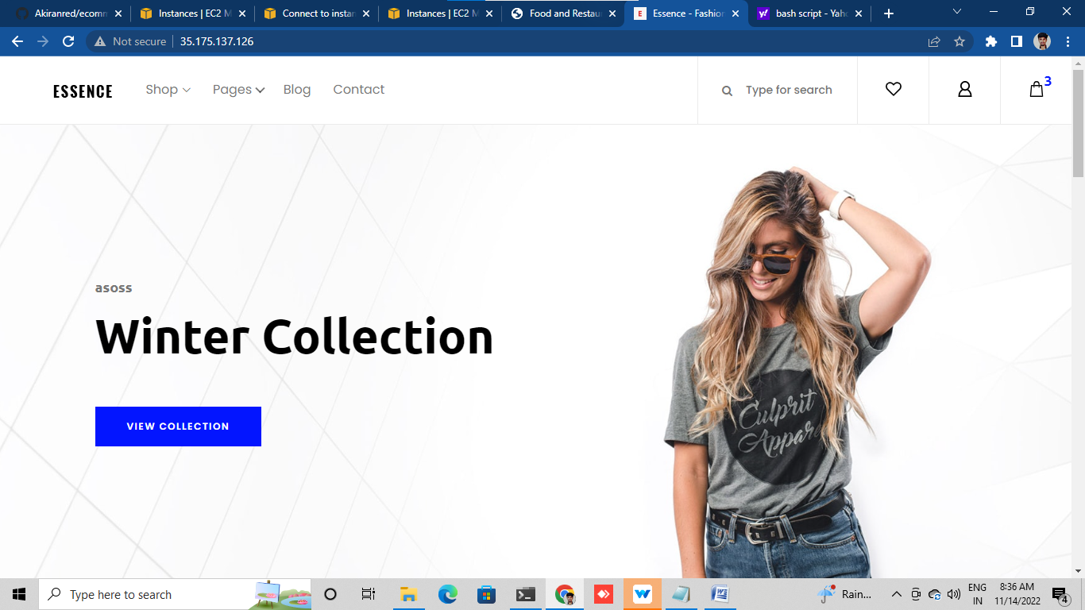

* Go to Load Balancer
* Create a Load balancer

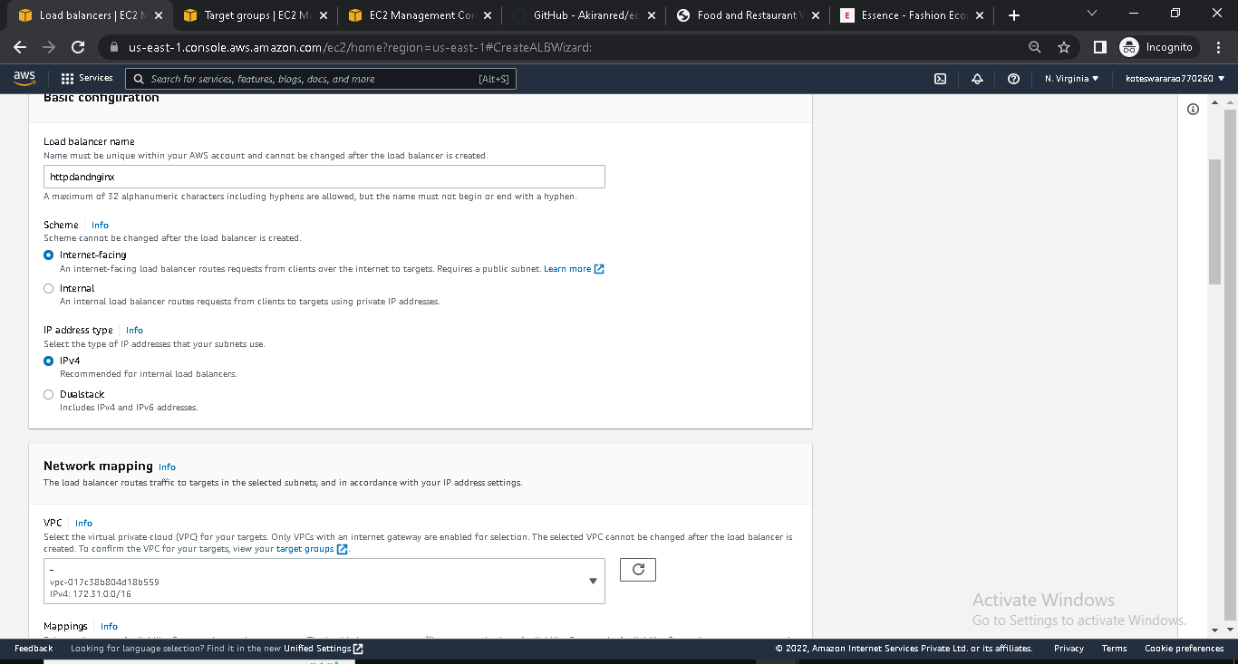

* In, Load Balancer we create Target group

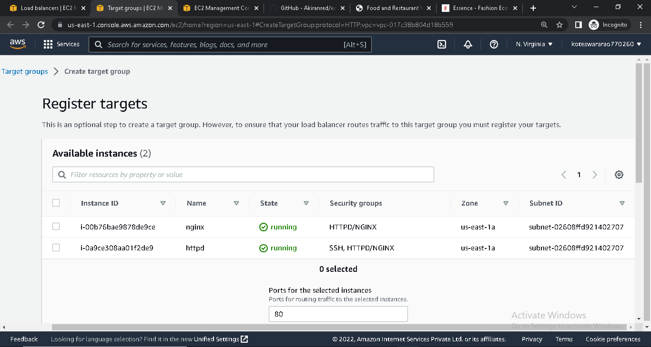

* In target group we give heath checks
* Include the instances
* Create target group

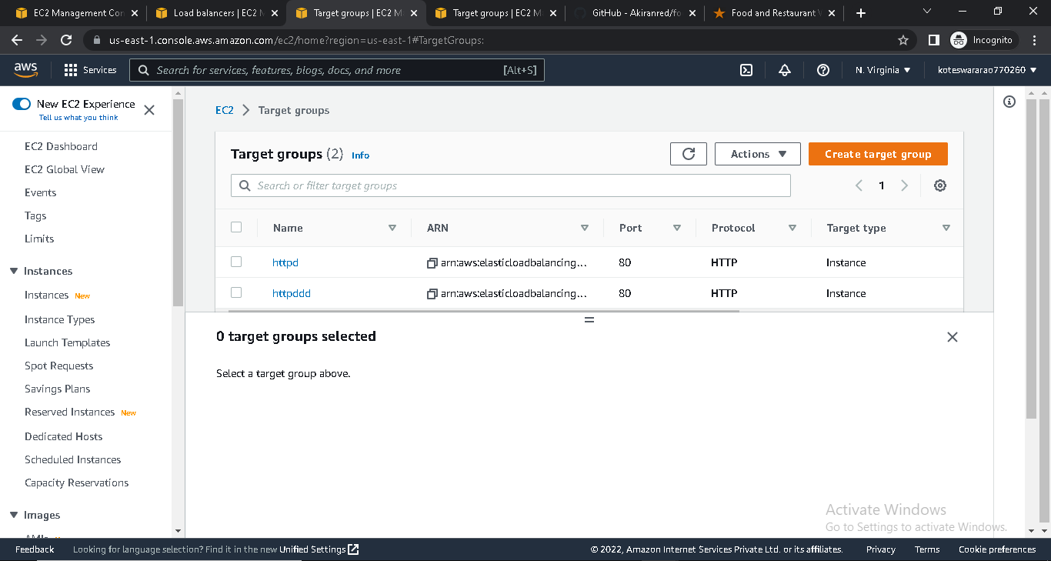

* In Load Balancer select the target group

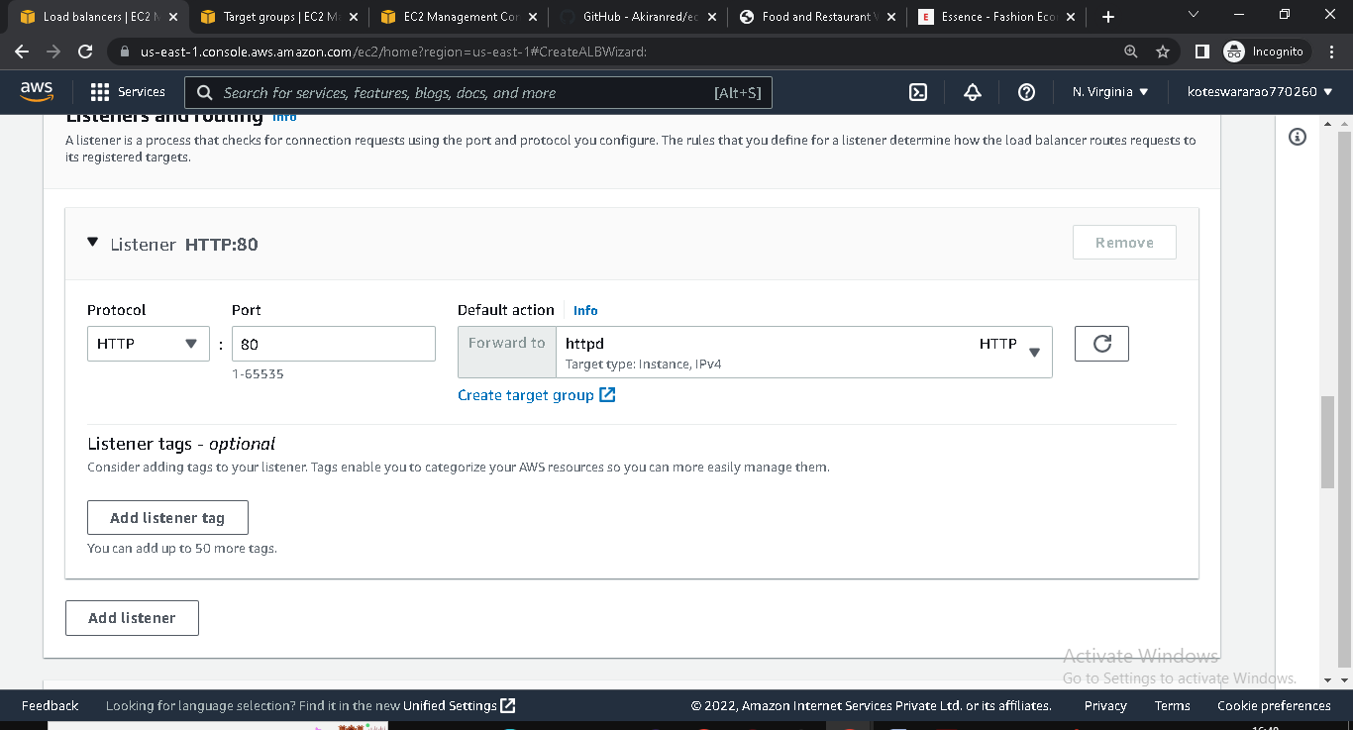

* Create Load Balancer

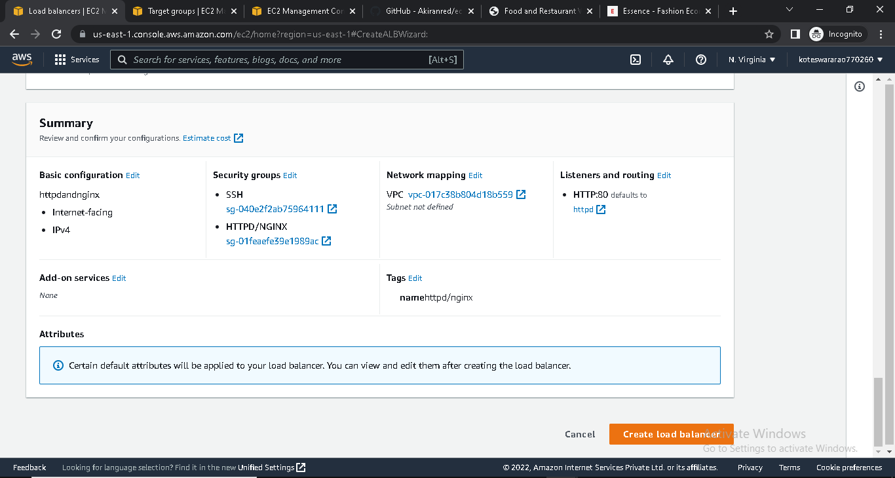

* Copy the DNS address

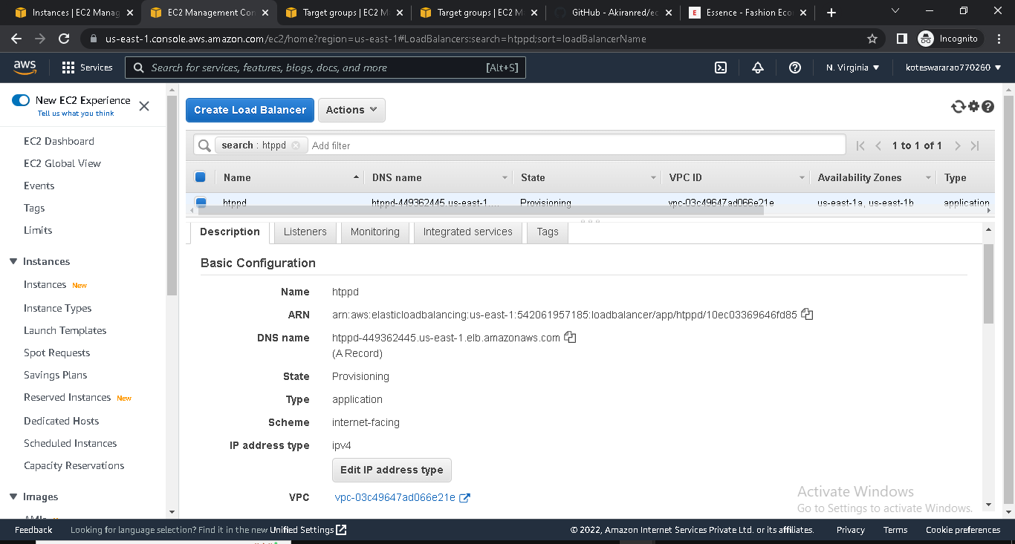

* Paste it in browser and it will show food/ecomm application(alternatively)



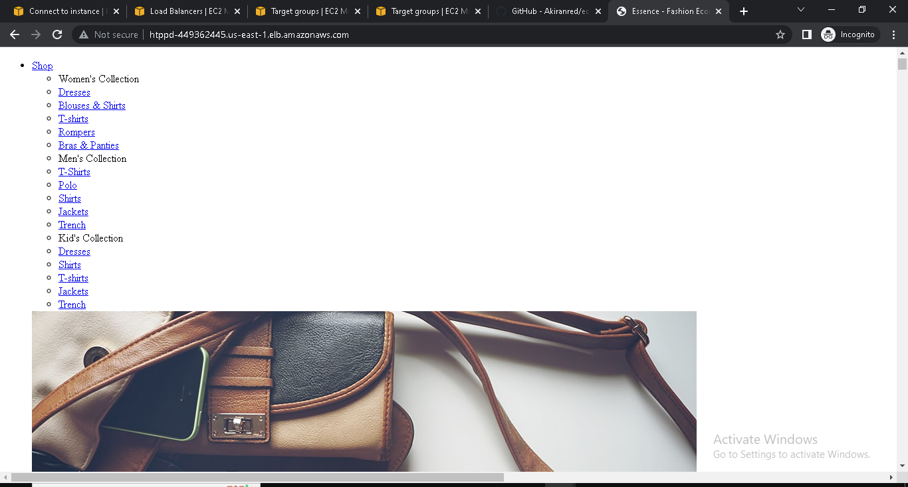

**LAUNCH CONFIGURATION AND AUTO SCALING**

* Login into AWS console
* Go to EC2 and click on Auto Scaling

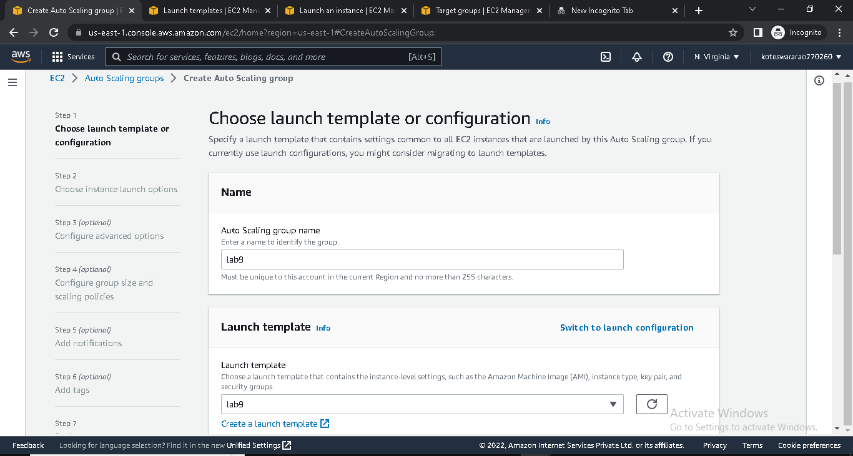

* Click on create launch template. It will go into launch template

**Launch configuration and template:-**

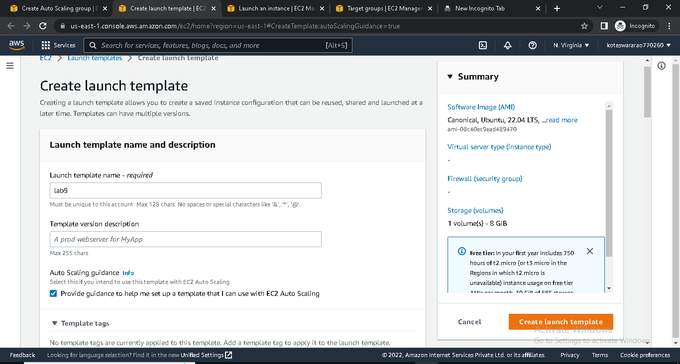

* Choose AMI Ubuntu and t2.micro

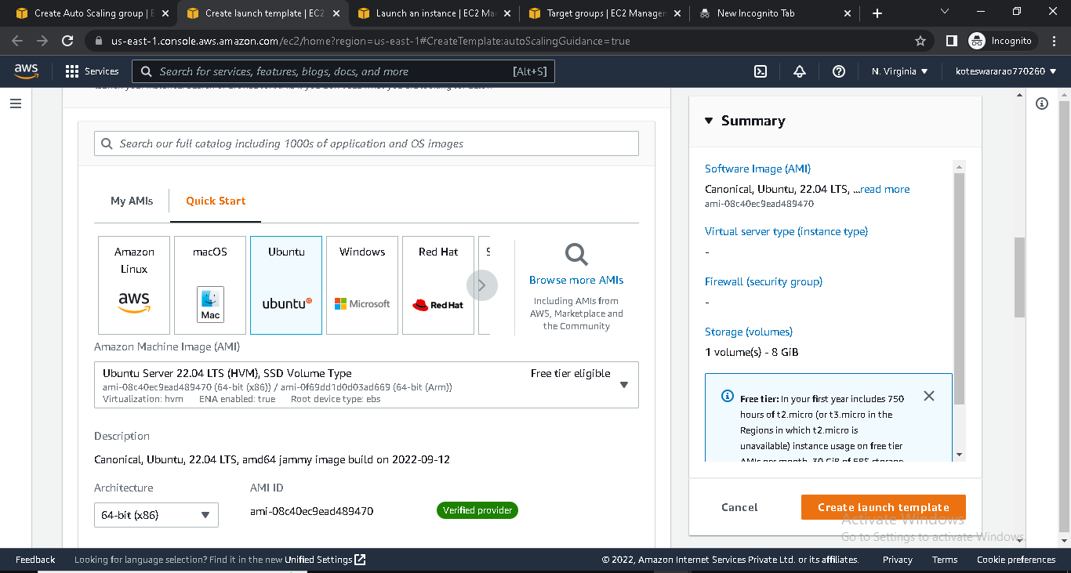

* Create Launch template
* Then , go to Auto scaling
* Choose launch template
* Choose instance launch option

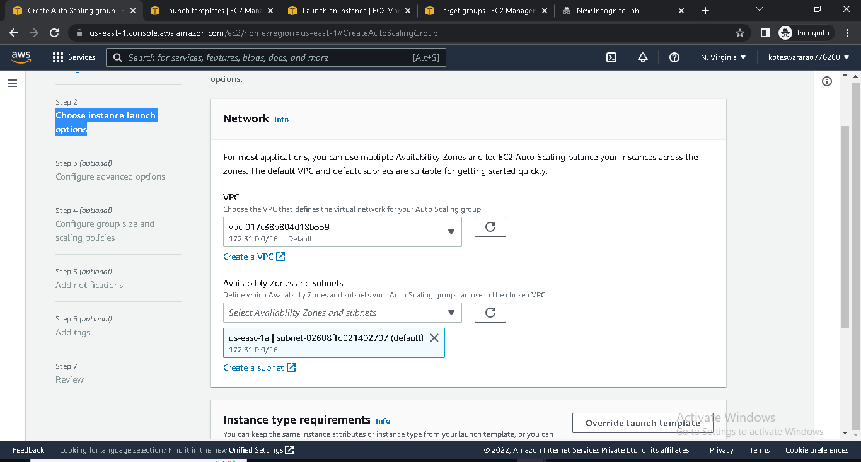

* Configure advanced options
* Configure group size and scaling policies

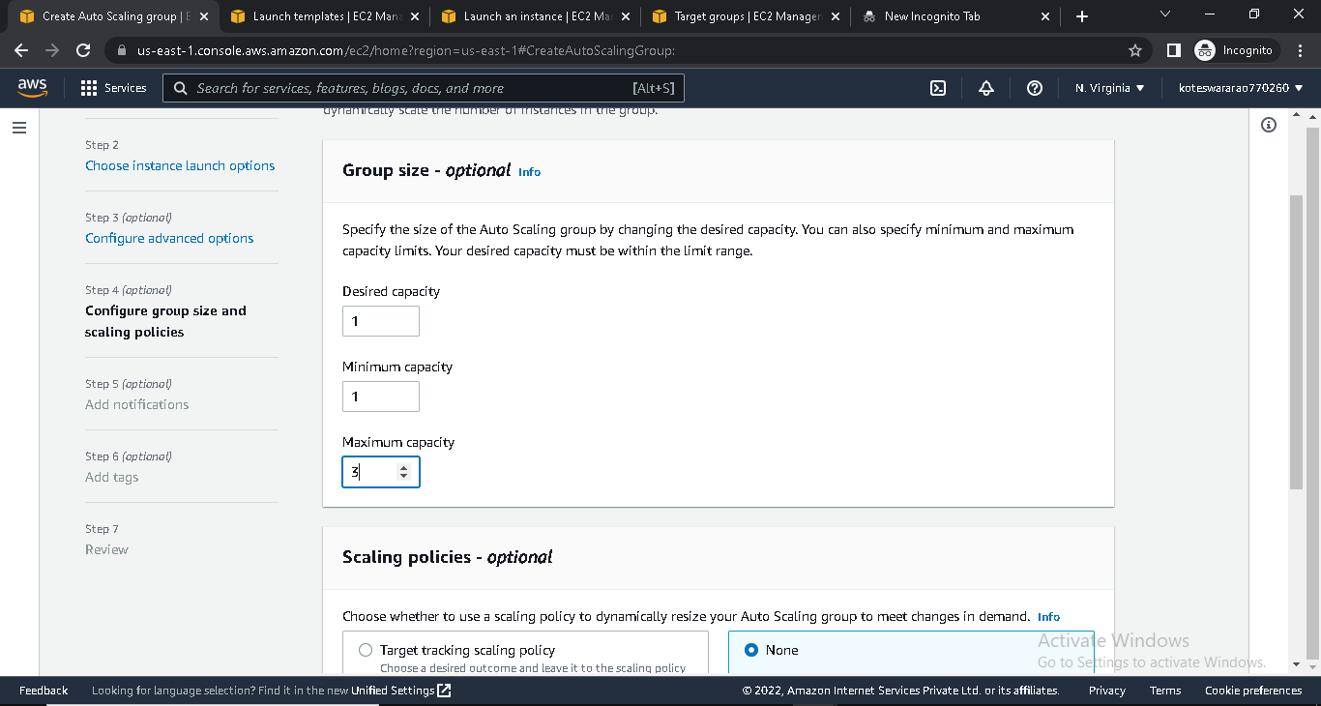

* Add notifications

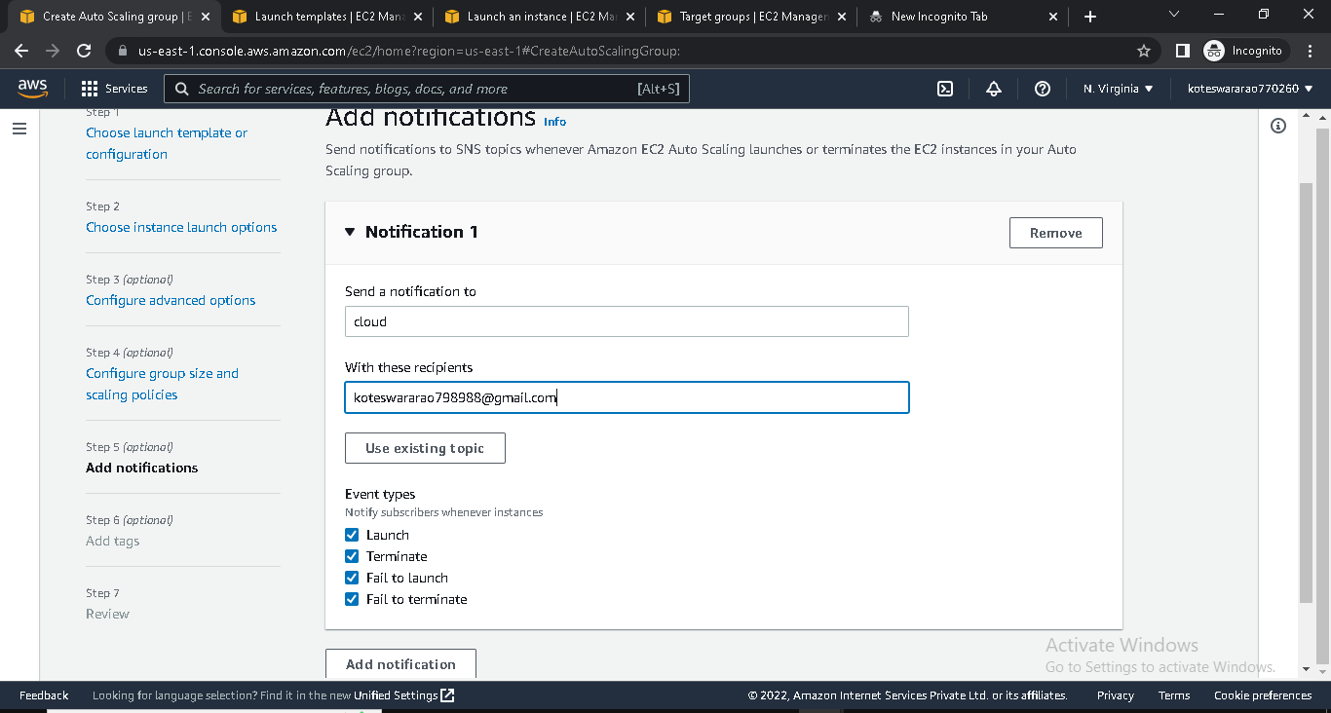

* Review and create Auto Scaling
* If we delete instance , it will create instance automatically

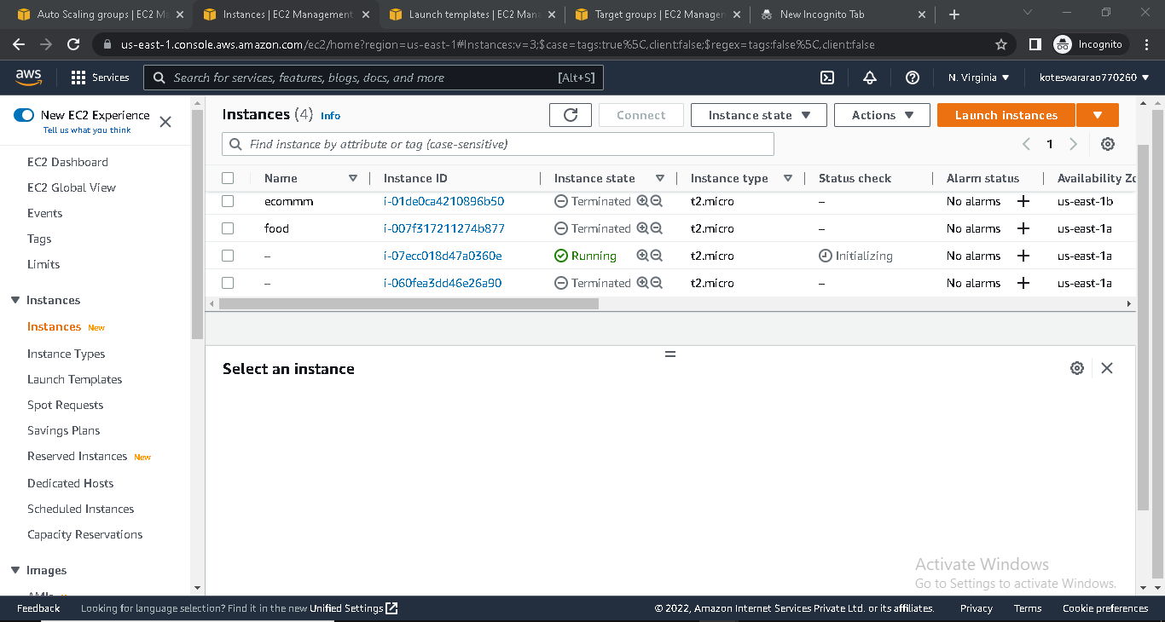

**RELATIONAL DATA BASE**

* Login into AWS console
* Go to EC2 and click on instance
* Launch instance with security group MYSQL (port-3306)

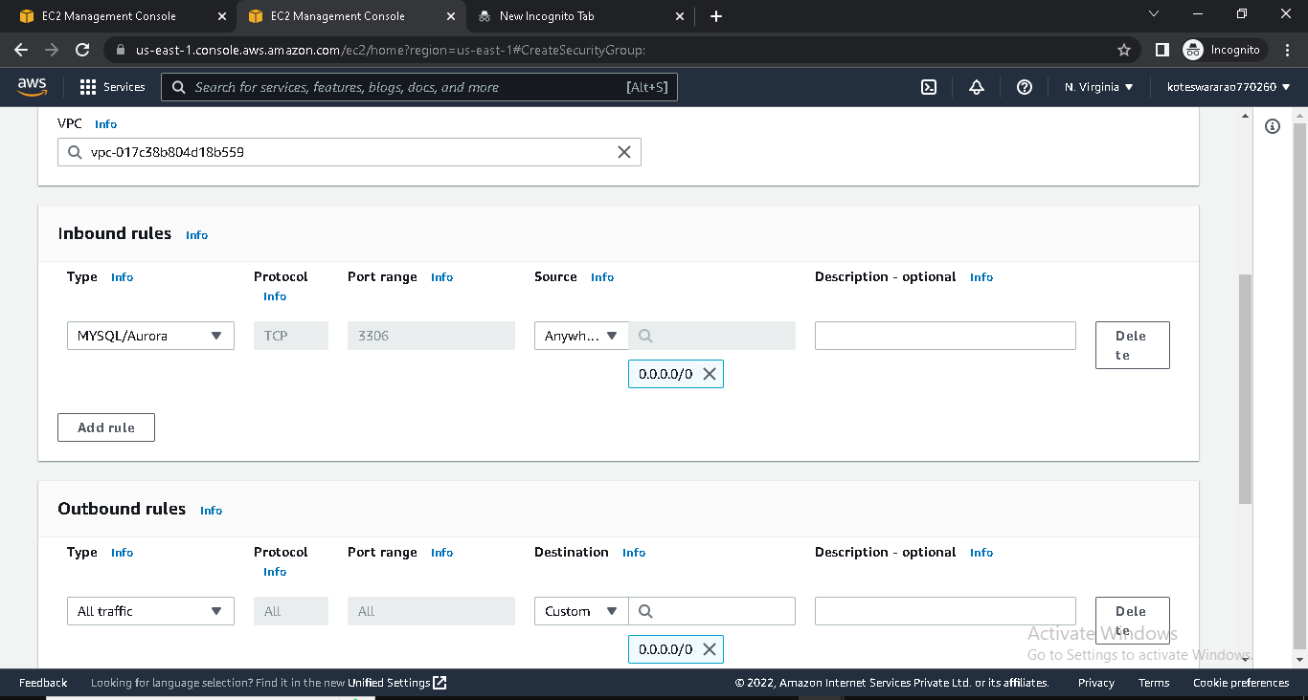

* Go to RDS

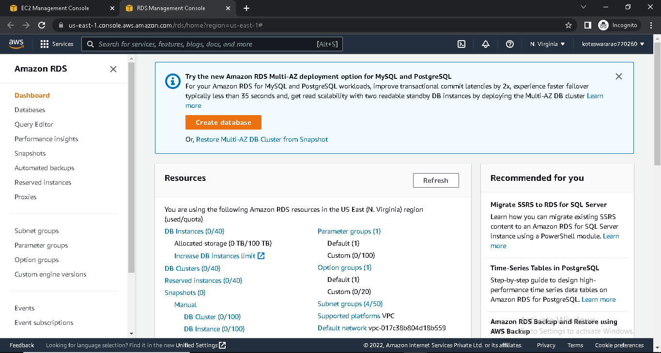

* Create database

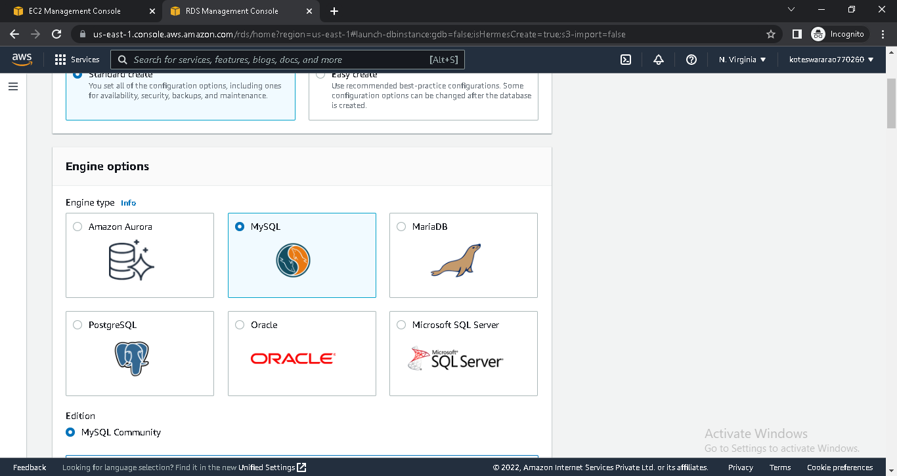

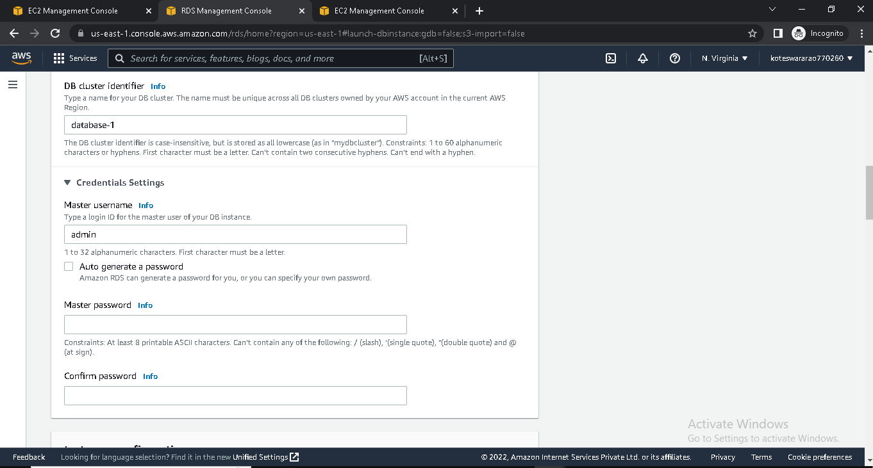

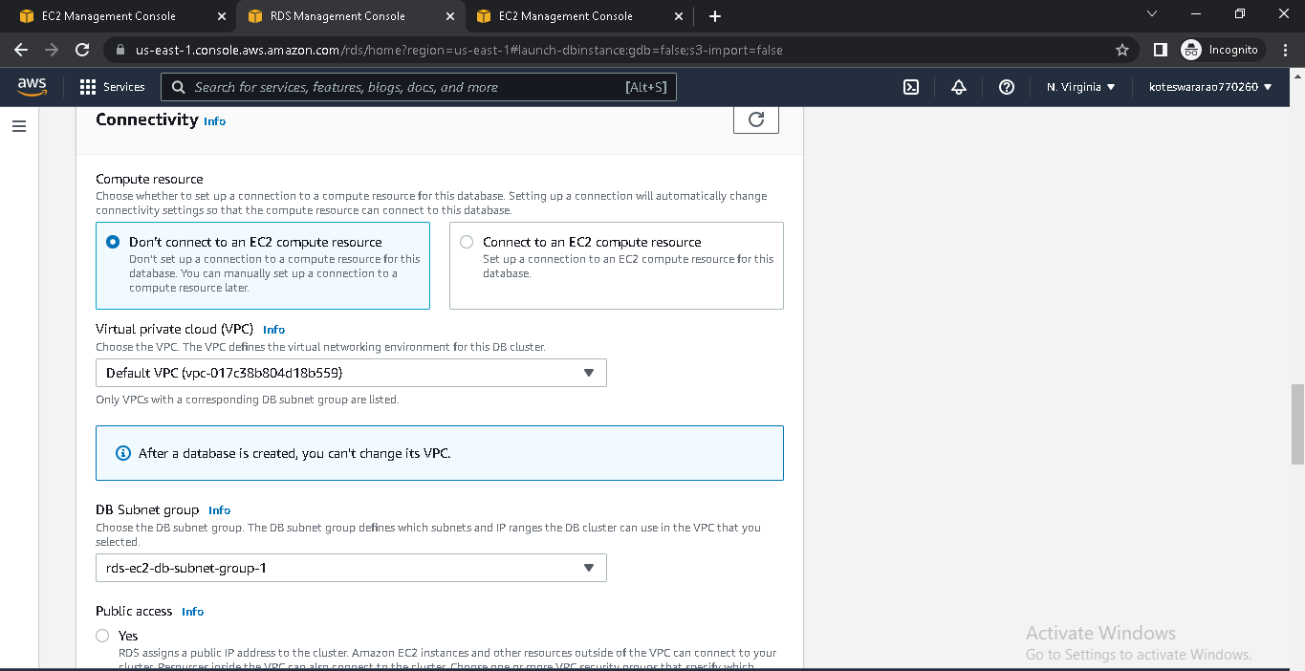

* Copy End point from created DataBase

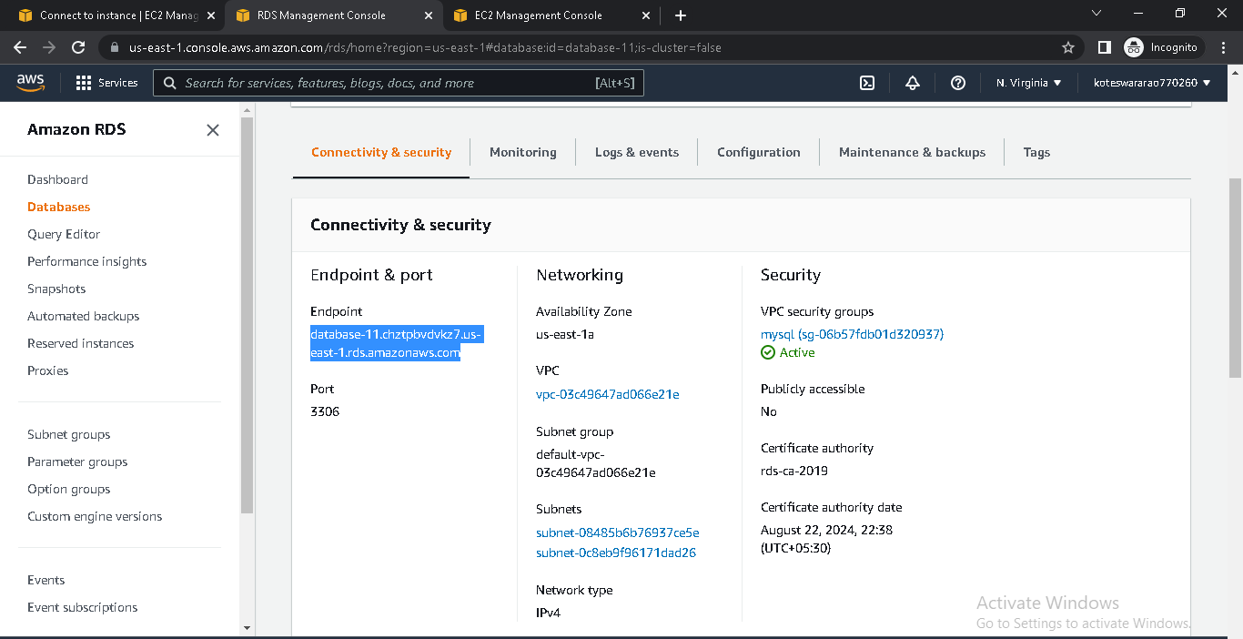

* Connect EC2 instance into terminal
* Install MYSQL by using sudo yum –y install mysql
* Connect database with instance by using

Mysql –h end point -u admin -p

* Enter password

